**ROBOTLINKING**

**THE SUPER KIT TUTORIAL**

**Preface**

### About RobotLinking

RobotLinking is a technology company focused on 3D Printer, Raspberry Pi and Arduino open source community development. Committed to the promotion of open source culture, we strive to bring the fun of electronics making to people all around the world and enable everyone to be a maker. Our products include learning kits, development boards, robots, sensor modules, development tools and printer machine. In addition to high quality products, RobotLinking also offers video tutorials to help your own project. If you have interest in open source or making something cool, welcome to join us! Visit [www.RobotLinking.com](http://www.sunfounder.com/) for more!

### About super Kit

This super kit is suitable for RobotLinking Uno, RobotLinking Mega 2560, RobotLinking Duemilanove and RobotLinking Nano. All the code in this user guide is also compatible with these boards.

Our RobotLinking board is fully compatible with Arduino.

This kit walks you through the basics of using the RobotLinking board in a hands-on way. You'll learn through building several creative projects. The kit includes a selection of the most common and useful electronic components. Starting from the basics of electronics, to more complex projects, the kit will help you control the physical world with components.

In this book, we will show you circuits with both realistic illustrations and schematic diagrams. You can go to our official website [www.RobotLinking.com](http://www.sunfounder.com/) to download related code.

If you have any questions, please send an email to [support@RobotLinking.com](mailto:support@sunfounder.com). You can also leave a message and share your projects on our forum.

**Contents**

Preface................................................................................................................................................................ 1

Components List............................................................................................................................................... 3

Lesson 1 Blinking LED ................................................................................................................................... 10

Lesson 2 Controlling an LED by Button..................................................................................................... 13

Lesson 3 Controlling LED by PWM............................................................................................................. 17

Lesson 4 Controlling an LED by Potentiometer....................................................................................... 21

Lesson 5 Flowing LED Lights ....................................................................................................................... 24

Lesson 6 RGB LED .......................................................................................................................................... 27

Lesson 7 DC Motor Control ......................................................................................................................... 30

Lesson 8 LCD1602.......................................................................................................................................... 34

Lesson 9 Serial Monitor ................................................................................................................................ 37

Lesson 10 7-Segment Display ..................................................................................................................... 41

Lesson 11 74HC595 ....................................................................................................................................... 46

Lesson 12 Dot-Matrix Display...................................................................................................................... 50

Lesson 13 NE555 Timer ................................................................................................................................ 55

Lesson 14 Rotary Encoder ............................................................................................................................ 59

Lesson 15 ADXL335 ....................................................................................................................................... 63

Lesson 16 Simple Creation - Light Alarm ................................................................................................. 66

Lesson 17 Simple Creation - Traffic Light ................................................................................................. 69

Lesson 18 Simple Creation - Digital Dice ................................................................................................. 72

Lesson 19 Simple Creation - Small Fan ..................................................................................................... 75

**Components List**

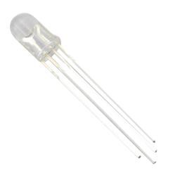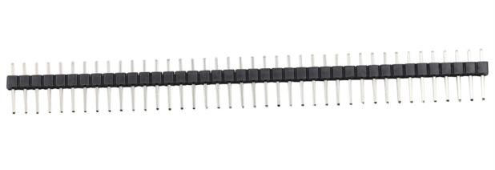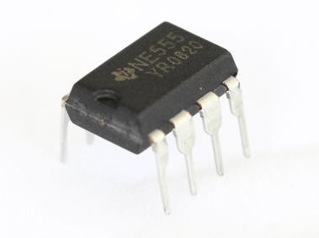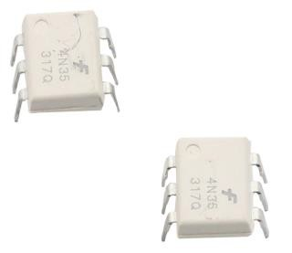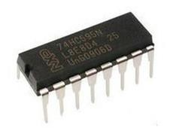

|  |  |  |  |
| --- | --- | --- | --- |
| No | Product Name | Quantity | Picture |
| 1 | RGB LED | 1 |  |
| 2 | Pin Header | 40 |  |
| 3 | 555 Timer IC | 1 |  |
| 4 | Optocoupler (4N35) | 2 |  |
| 5 | Shift Register (74HC595) | 2 |  |

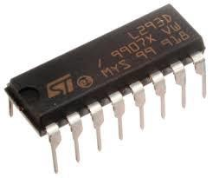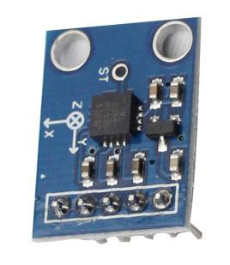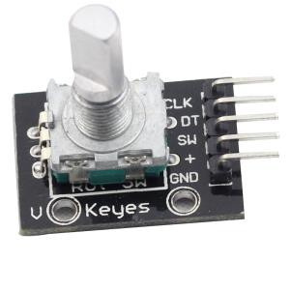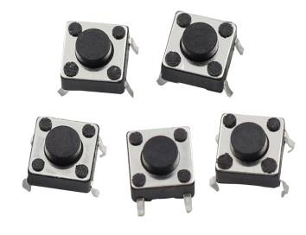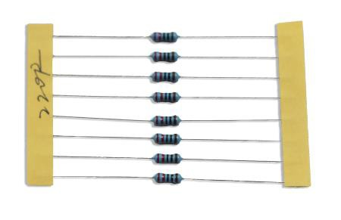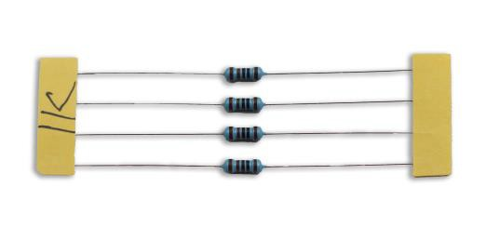

|  |  |  |  |
| --- | --- | --- | --- |
| 6 | L293D | 1 |  |
| 7 | Accelerometer ADXL335 | 1 |  |
| 8 | Rotary Encoder | 1 |  |
| 9 | Push-Button (small) | 5 |  |
| 10 | Resistor (220Ω) | 8 |  |
| 11 | Resistor (1kΩ) | 4 |  |

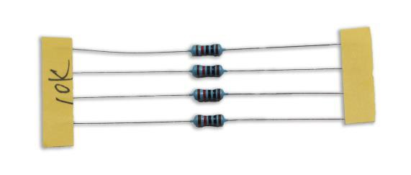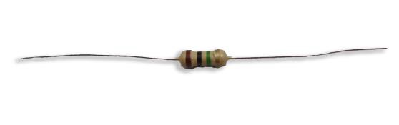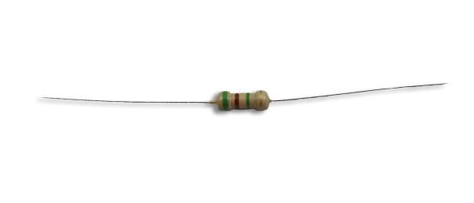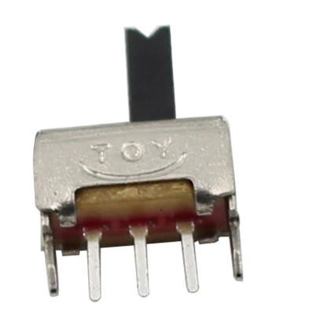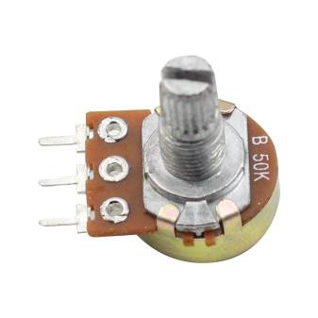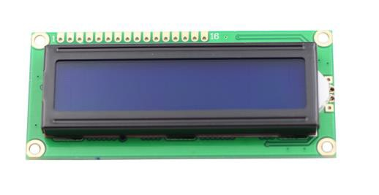

|  |  |  |  |
| --- | --- | --- | --- |
| 12 | Resistor (10kΩ) | 4 |  |
| 13 | Resistor (1MΩ) | 1 |  |
| 14 | Resistor (5.1MΩ) | 1 |  |
| 15 | Switch | 1 |  |
| 16 | Potentiometer (50kΩ) | 1 |  |
| 17 | LCD Character Display 16*2 | 1 |  |

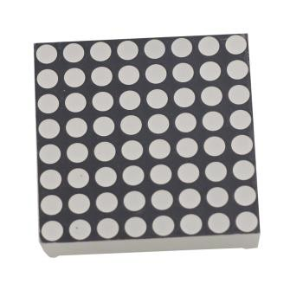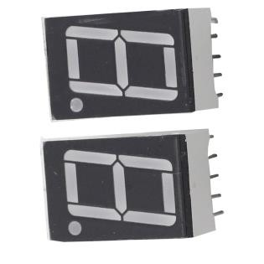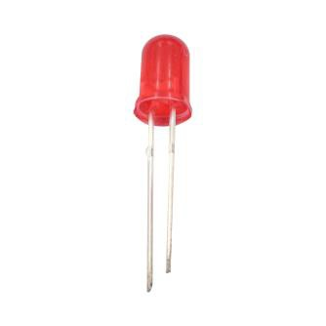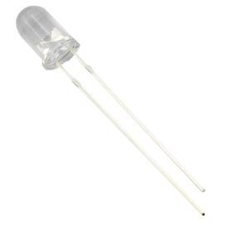

|  |  |  |  |
| --- | --- | --- | --- |
| 18 | Dot Matrix Display 8*8 | 1 |  |
| 19 | 7-Segment Character Display | 2 |  |
| 20 | DC Motor | 1 |  |
| 21 | LED (red) | 16 |  |
| 22 | LED (white) | 2 |  |

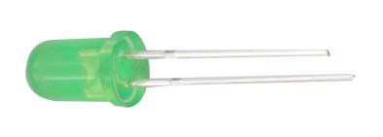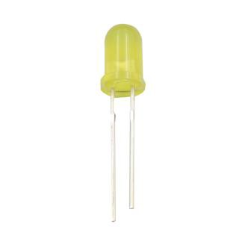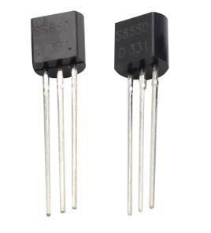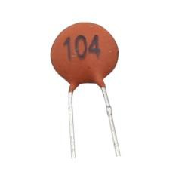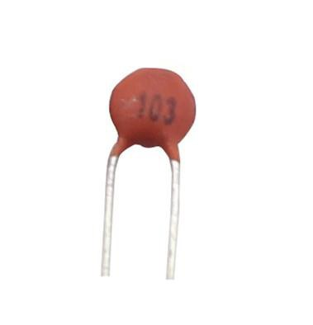

|  |  |  |  |
| --- | --- | --- | --- |
| 23 | LED (green) | 2 |  |
| 24 | LED (yellow) | 2 |  |
| 25 | Transistor NPN | 2 |  |
| 26 | Transistor PNP | 2 |  |
| 27 | Capacitor Ceramic 100nF | 4 |  |
| 28 | Capacitor Ceramic 10nF | 4 |  |

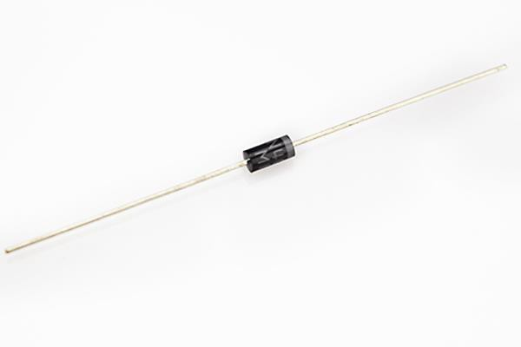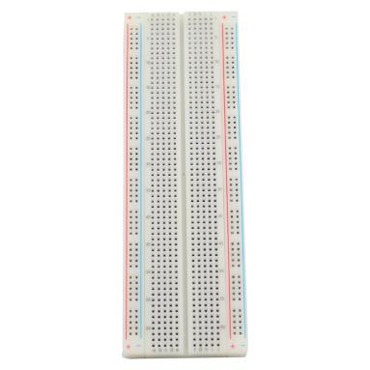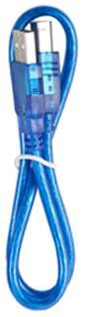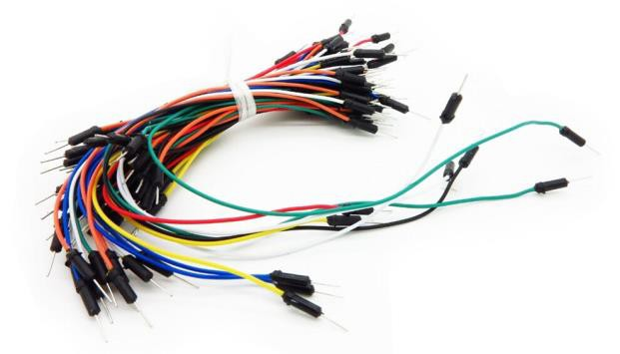

|  |  |  |  |
| --- | --- | --- | --- |
| 29 | Diode Rectifier (1N4007) | 4 |  |
| 30 | Breadboard | 1 |  |
| 31 | USB Cable | 1 |  |
| 32 | Male-to-Male Jumper Wire | 65 |  |

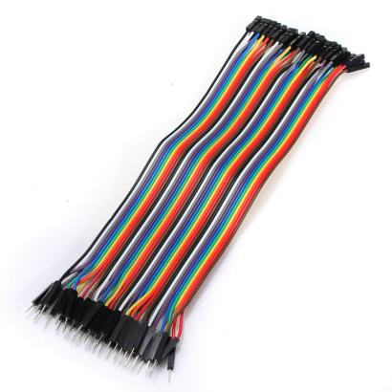

|  |  |  |  |
| --- | --- | --- | --- |
| 33 | Female-to-Male Dupont Wire | 20 |  |
| 34 | Piezo Buzzer | 1 |  |
| 35 | Fan | 1 |  |

**Note:**

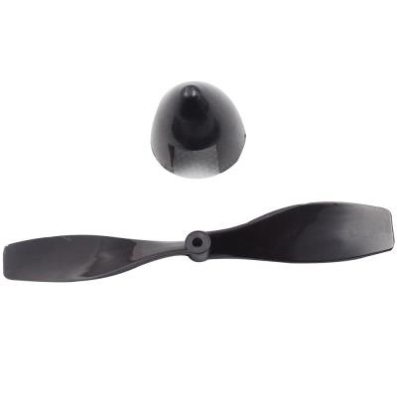

After unpacking, please check that the number of components is correct and that all components are in good condition.

**Lesson 1 Blinking LED**

**Introduction**

In this lesson, we will start learning how to use the RobotLinking Uno board by lighting up an LED and having it blink once per second.

**Components**

- 1 * RobotLinking Uno board

- 1 * USB cable

- 1 * Resistor (220Ω)

- LED * 1

- Jumper wires

- 1 * Breadboard

**Principle**

Semiconductor light-emitting diode is a type of component which can turn electric energy into light energy via PN junctions. By wavelength, it can be categorized into laser diode, infrared light-emitting diode and visible light-emitting diode which is usually known as light-emitting diode (LED). LEDs are usually red, yellow, green, blue, or color-changing. Color-changing LEDs change their color with different voltages.

Before connecting any circuit, you should know the parameters of the components in the circuit, such as their operating voltage, operating circuit, etc. You should connect a current-limiting resistor when an LED is used or else the LED can become burned due to excessive current. In this experiment, the operating voltage of the LED is 1.5V–2.0V and the operating current is

10mA–20mA. The power supply voltage of the RobotLinking Uno board is 5V, the operating voltage of the LED we choose is 1.7V, and its operating current is 15mA. The current-limiting

resistance equals total voltage subtracted by LED voltage, then divided by current. In this case,

that would be (5-1.7)/0.015. Thus, the current-limiting resistance equals 220Ω.

**Experimental Procedures**

**Step 1:** Connect circuit as shown in the following diagram:

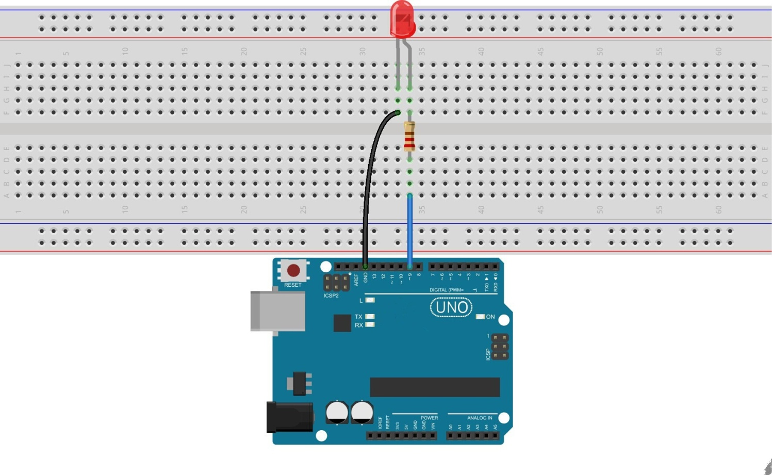

The corresponding schematic diagram is as follows:

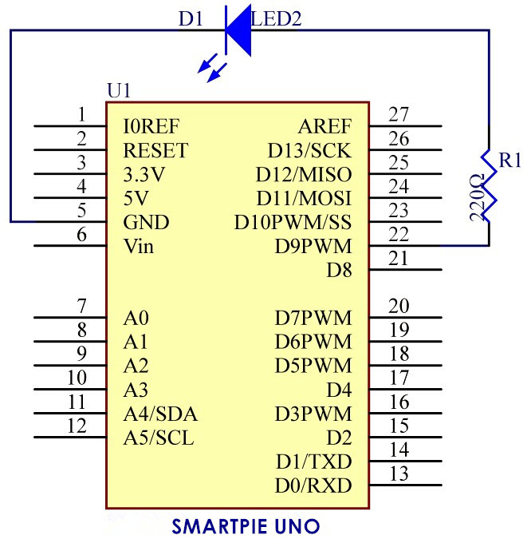

**Step 2:** Program (please go to our official website  [www.RobotLinking.com](http://www.sunfounder.com/) to download related

code or get the code from the CD.)

**Step 3:** Compile the program

**Step 4:** Burn the program into RobotLinking Uno board

You should now see the LED on the board blinking.

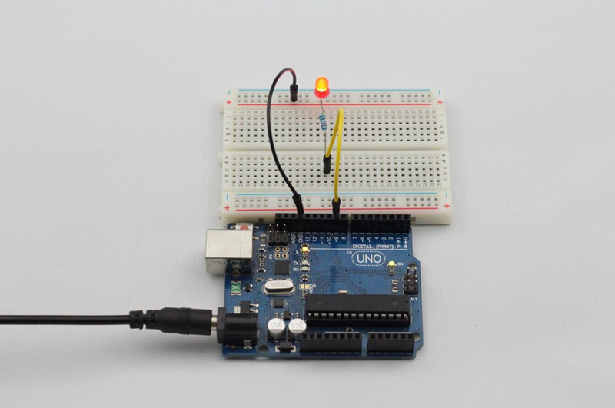

**Experimental Summary**

Through this experiment, we have learned how to light up an LED. You can also change the blinking frequency of the LED by changing the num value in the delay function delay (num). For example, if the delay function is changed to delay (250), you will find that the LED blinks more quickly.

**Lesson 2 Controlling an LED by Button**

**Introduction**

In this experiment, we will learn how to turn a single LED on or off through the use of an I/O port and button switch. The "I/O port" refers to the INPUT and OUTPUT port. We will use the input function of the RobotLinking Uno I/O port to read the output of an external device. Since the RobotLinking Uno board itself has an LED (connected to Pin 13), we will use the LED to accomplish this experiment for convenience.

**Components**

- 1 * RobotLinking Uno board

- 1 * USB cable

- 1 * Button

- 1 * Resistor (10kΩ)

- Jumper wires

- 1 * Breadboard

**Principle**

Buttons are a common component used to control electronic devices. They are usually used as switches to connect or disconnect circuits. Although buttons come in a variety of sizes and shapes, the one used in this experiment will be a 6mm mini-button as shown in the following pictures. Pins pointed out by the arrows of same color are meant to be connected.

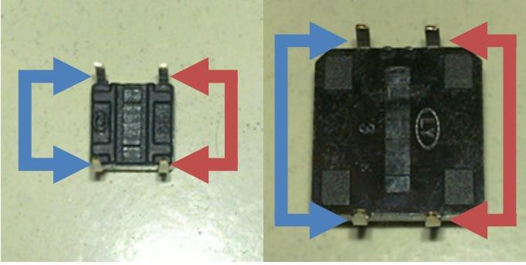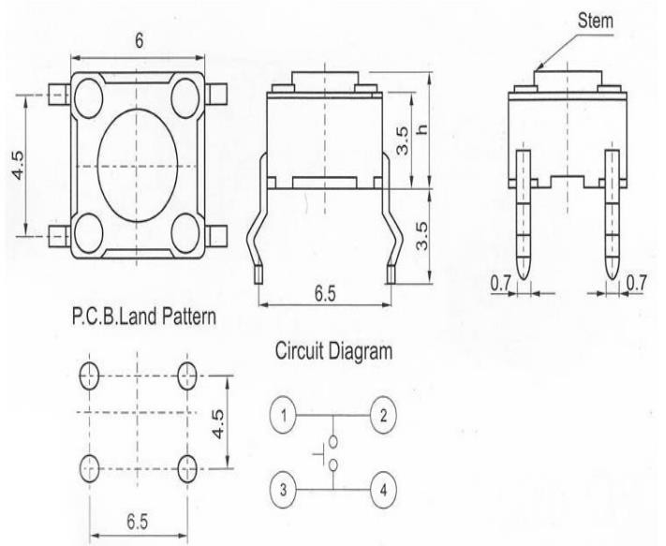

When the button is pressed, the pins pointed by the blue arrows will connect to the pins

pointed by the red arrows.

Generally, the button switch is directly connected in an LED circuit in order to turn the LED on or off. This connection is relatively simple. However, sometimes the LED will light up automatically without pressing the button, which is caused by various interferences. In order to avoid these external interferences, we will connect a pull-down resistor, that is, connect a 1K–

10KΩ resistor between the button port and the GND. The function of the pull-down resistor is to consume external interferences while connected to the GND for as long as the button switch is turned off.

This circuit connection is widely used in numerous circuits and electronic devices. For example, if you press any button on your mobile phone, the backlight will light up.

**Experimental Procedures**

**Step 1:** Connect circuit as shown in the following diagram:

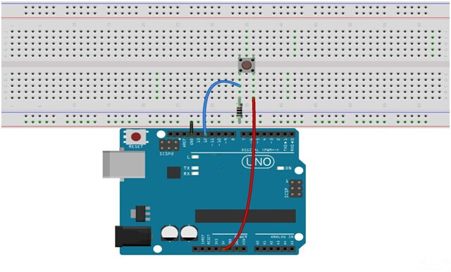

The corresponding circuit schematic diagram is as follows:

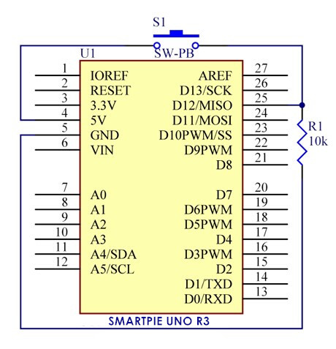

**Step 2:** Program (please go to our official website  [www.RobotLinking.com](http://www.sunfounder.com/) to download related

code or get the code from the CD.)

**Step 3:** Compile the program

**Step 4:** Burn the program into RobotLinking Uno board

If you press the button, the LED on the RobotLinking Uno board will light up.

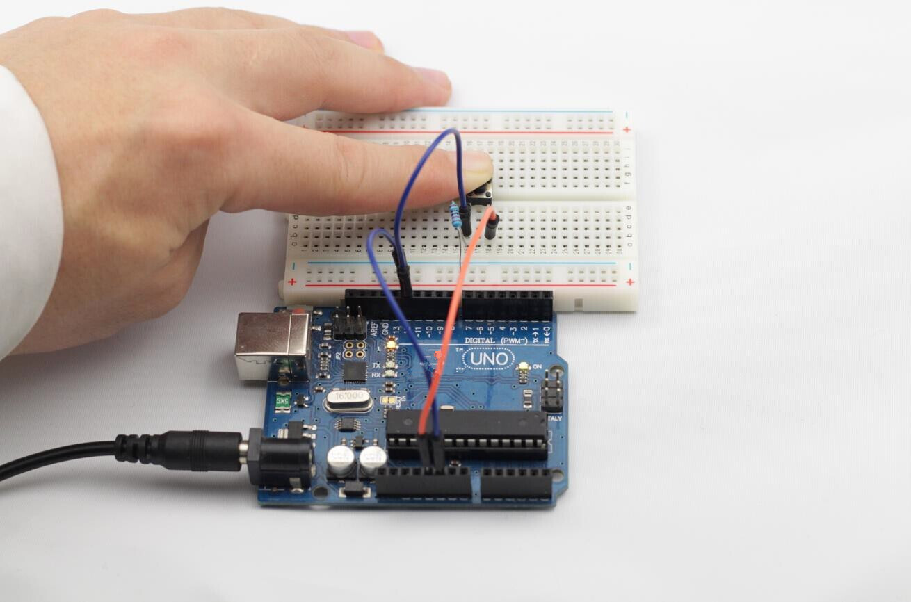

**Experimental Summary**

Buttons are a very simple, very practical technology that is surprisingly easy to master. If you feel as though you’re struggling, check out our video tutorials on [www.RobotLinking.com](http://www.sunfounder.com/) or ask us questions on our forum.

**Lesson 3 Controlling LED by PWM**

**Introduction**

Let’s try something a little easier – gradually changing the luminance of an LED through programming. Since the pulsing light looks like breathing, so we give it a magical name - Breathing LED. We’ll accomplish this effect with PWM (pulse-width modulation).

**Components**

- 1 * RobotLinking Uno board

- 1 * Breadboard

- Jumper wires

- 1 * LED

- 1 * Resistor (220Ω)

- 1 * USB cable

**Principle**

Before we talk about PWM, let’s have a look at its applications. PWM has been successfully applied in motor speed regulation, steering angle control, light intensity control, and signal output. For example, when PWM is applied to a horn, it will make a noise. Knowing how to apply PWM is great, but what is it?

Pulse Width Modulation, or PWM, is a technique for getting analog results with digital means. Digital control is used to create a square wave, a signal switched between on and off. This on- off pattern can simulate voltages in between full on (5 Volts) and off (0 Volts) by changing the portion of the time the signal spends on versus the time that the signal spends off. The duration of "on time" is called the pulse width. To get varying analog values, you change, or modulate, that pulse width. If you repeat this on-off pattern fast enough with an LED for example, the result is as if the signal is a steady voltage between 0 and 5V controlling the brightness of the LED. (See the PWM description on the official website of Arduino).

!.V

OV



75' 25':-0 75% 25' 75% 25:

.:3.*75V*

bV

OV



!:O: ::1 !1.*1* !() .) !.(

.2 . 5V

UV n...... lV

We can see from the top oscillogram that the amplitude of the DC voltage output is 5V Howeverthe actual voltage output is only 3.75V through PWM because the high level only takes u p 75% of the total voltage within a period

H ere is an introdu ction to the three basic parameters of PWM:

Control signal*u*

011 *U*

*Upwm*

*(mean* ν*allle)*

Off *0*

1+- J t

Duty cycleD [%)

1+---

Peri od1

IOO%

1. The term ["duty cycl e](http://en.wikipedia.org/wiki/Duty_cycle)" describes the propo ion of "on" time to the regular interval or period oftime

2. The term "period" describes the reciprocal of pul ses in one second

3. The voltage amplitude here is OV-5V

18

**Experimental Procedures**

**Step 1:** Connect circuit as shown in the following diagram:

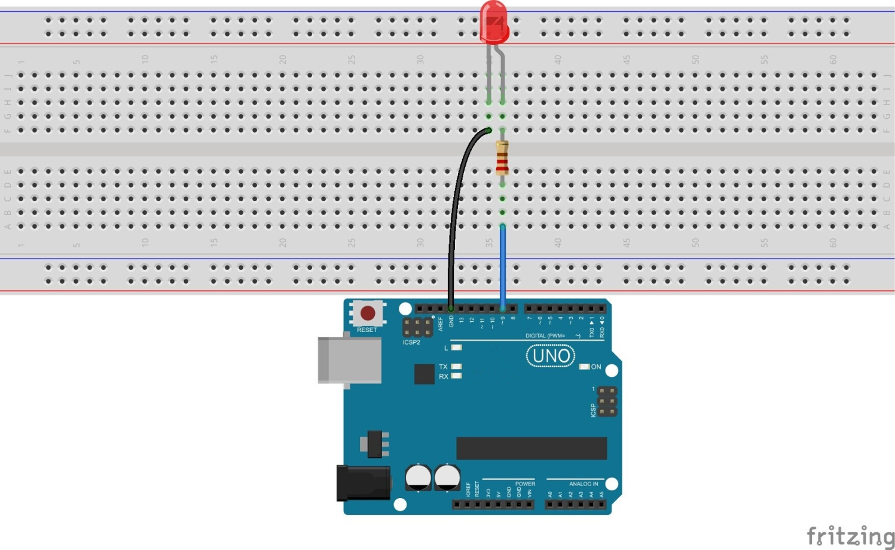

The corresponding schematic diagram is as follows:

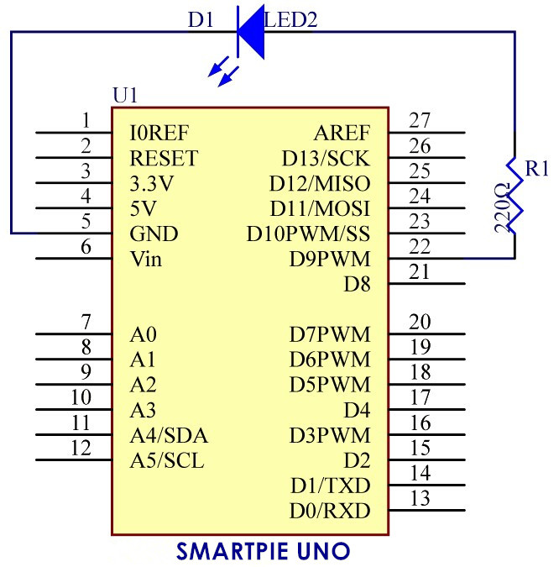

**Step 2:** Program (please go to our official website  [www.RobotLinking.com](http://www.sunfounder.com/) to download related

code or get the code from the CD.)

**Step 3:** Compile the program

**Step 4:** Burn the program into RobotLinking Uno board

Here you should see the luminance of the LED regularly vary.

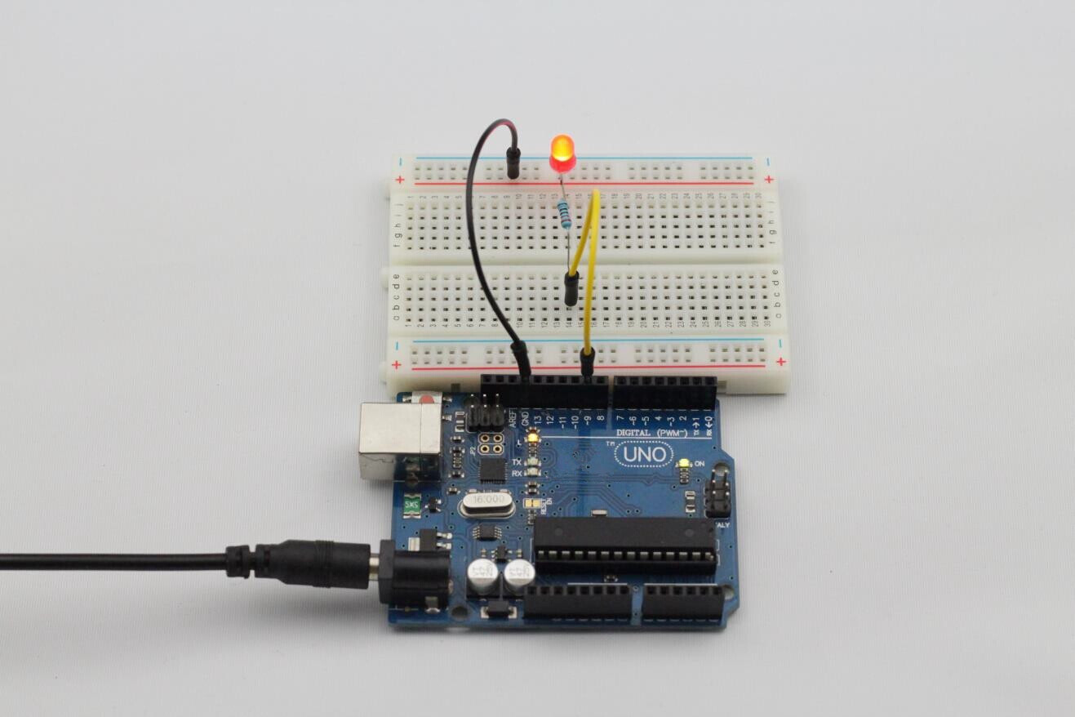

**Experimental Summary**

Having completed this experiment, do you feel a great sense of accomplishment? Prepare yourself because things will quickly become more complicated!

**Lesson 4 Controlling an LED by Potentiometer**

**Introduction**

In the last experiment, we learned how to control an LED through PWM by only using software, which is interesting though slightly abstract. In this lesson, we’ll learn controlling and changing an LED luminance by rotating the shaft of a potentiometer.

**Components**

- 1 * RobotLinking Uno board

- 1 * Breadboard

- Jumper wires

- 1 * Resistor (220Ω)

- 1 * LED

- 1 * Potentiometer

- 1 * USB cable

**Principle**

A linear potentiometer is an analog electronic component. What’s the difference between analog and the digital? Simply put, the digital refers to on/off, high/low level with just two states, i.e. either 0 or 1. Yet the data states of analog signals are linear, for example, from 1 to

1000. The signal value changes over time instead of indicating an exact number. Analog signals include light intensity, humidity, temperature, and so on.

In this experiment we will use a potentiometer for an LED dimming so that the luminance of the

LED will vary more uniformly unlike the stepwise change of luminance in the last experiment.

What we mean by PWM here is the digitalization of analog signals, which is a process of approaching analog signals. Since the potentiometer inputs analog signals, it should be connected to analog input ports, i.e. A0-A5, instead of digital ports.

**Experimental Procedures**

**Step 1:** Connect circuit as shown in the following diagram:

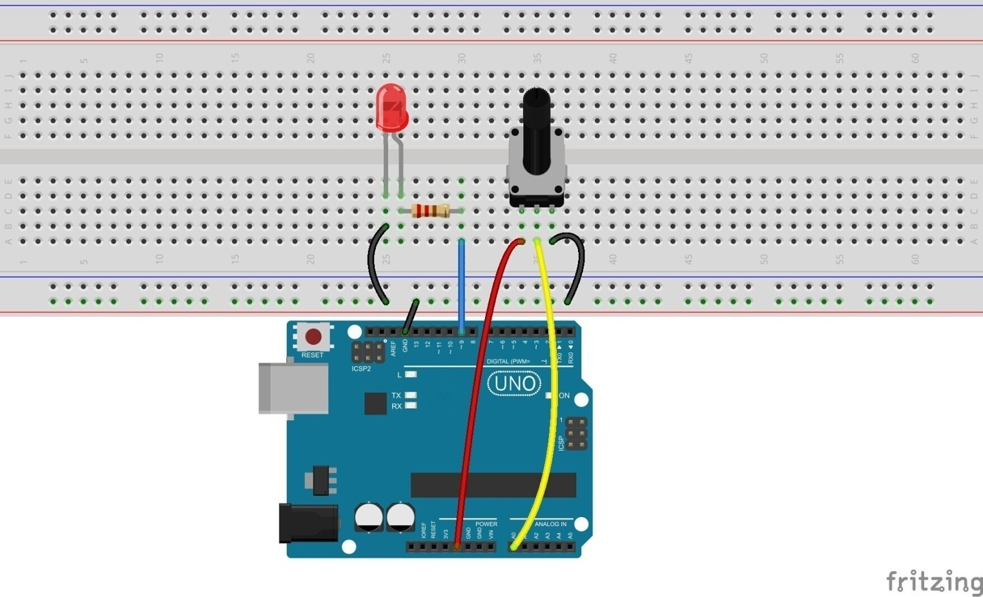

The corresponding schematic diagram is as follows:

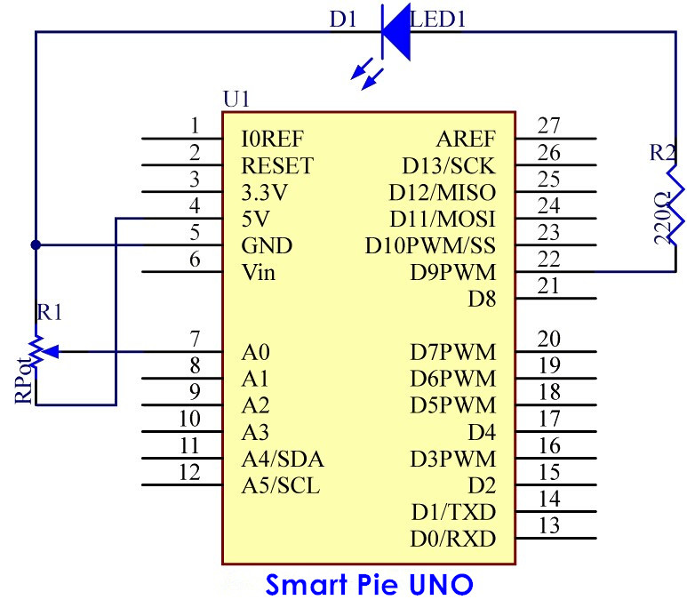

We can see that the potentiometer is connected to the A0 analog detection port of the

RobotLinking Uno, which can measure voltages from 0V to 5V. The corresponding returned value is from 0 to 1024. The measurement accuracy for voltage change is relatively high.

**Step 2:** Program (please go to our official website  [www.RobotLinking.com](http://www.sunfounder.com/) to download related code or get the code from the CD.)

**Step 3:** Debug the program

**Step 4:** Burn the program into RobotLinking Uno board

Rotate the shaft of the potentiometer and you should see the luminance of the LED change.

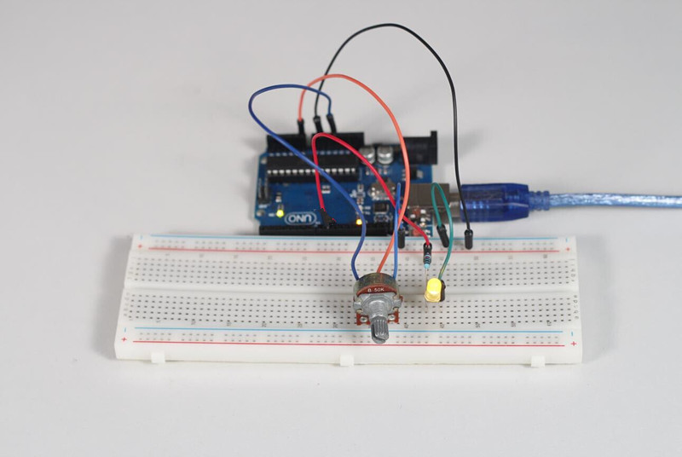

**Experimental Summary**

You have mastered the usage of potentiometer through this experiment. Next, you can modify the routine provided to achieve other functions.

**Lesson 5 Flowing LED Lights**

**Introduction**

In this lesson, we’ll conduct a simple yet interesting experiment – using LEDs to create flowing LED lights. As the name implies, these flowing lights are made up of eight LEDs in a row which successively light up and dim one after another like flowing water.

**Components**

- 1 * RobotLinking Uno board

- 1 * Breadboard

- Jumper wires

- 8 * LED

- 8 * Resistor (220Ω)

- 1 * USB cable

**Principle**

The principle of this experiment is simply to turn eight LEDs on in turn.

**Experimental Procedures**

**Step 1:** Connect circuit as shown in the following diagram:

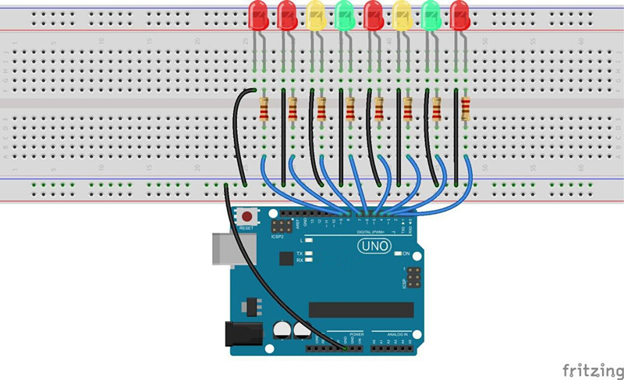

The corresponding schematic diagram is as follows:

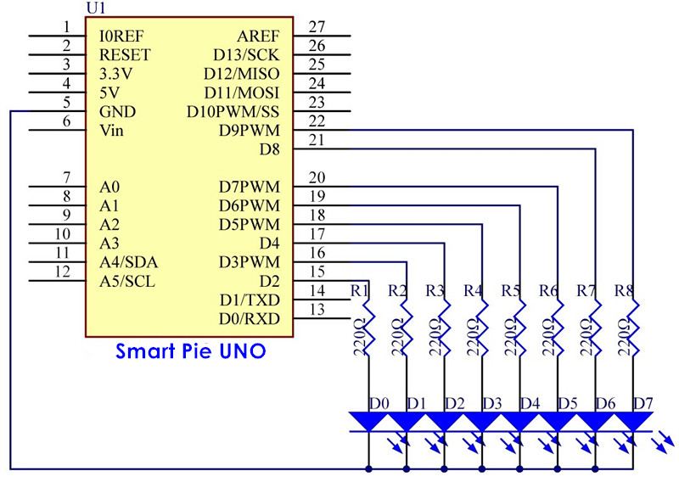

**Step 2:** Program (please go to our official website  [www.RobotLinking.com](http://www.sunfounder.com/) to download related code or get the code from the CD.)

**Step 3:** Compile the program

**Step 4:** Burn the program into RobotLinking Uno board

Eight LEDs will light up one by one from left to right, and then go out one by one from right to left. After that, the LEDs will light up one by one from right to left, and then go out one by one from left to right. This process will repeat indefinitely.

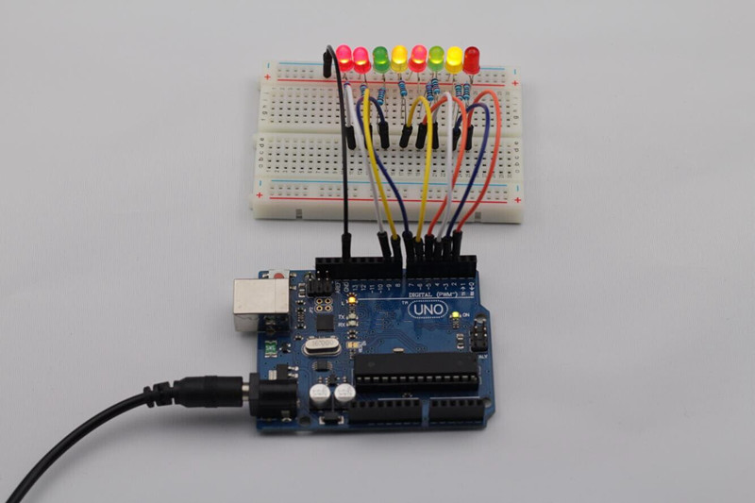

**Experimental Summary**

This simple experiment helps to increase proficiency in applying LEDs. Furthermore, you can modify the provided program to create all kinds of fantastic patterns!

**Lesson 6 RGB LED**

**Introduction**

For this lesson, we will use PWM to control a RGB LED and cause it to display multiple colors.

**Components**

- 1 * RGB LED

- 3 * Resistor (220Ω)

- 1 * Breadboard

- 1 * RobotLinking Uno board

- Jumper wires

- USB cable

**Principle**

**Color Principle of RGB**

RGB stands for the red, green, and blue color channels and is an industry color standard. RGB displays various new colors by changing the three channels and superimposing them, which, according to statistics, can create 16,777,216 different colors. If you say the color displayed doesn’t completely match a natural color, then it almost certainly cannot be differentiated with the naked eye.

Each of the three color channels of red, green, and blue has 255 stages of brightness. When the three primary colors are all 0, "LED light" is the darkest, that is, it turns off. When the three primary colors are all 255, "LED light" is the brightest. When superimposing the light emitted by the three primary colors, the colors will be mixed. However, the brightness is equal to the sum of all brightness, and the more you mix, the brighter the LED is. This process is known as additive mixing.

In this experiment, we will also use PWM which, if you’ve followed the lessons thus far, you already have a basic understanding of. Here we input any value between 0 and 255 to the three pins of the RGB LED to make it display different colors.

**Experimental Procedures**

**Step 1:** Connect circuit as shown in the following diagram:

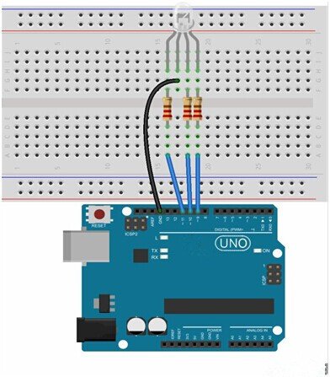

The corresponding schematic diagram is as follows:

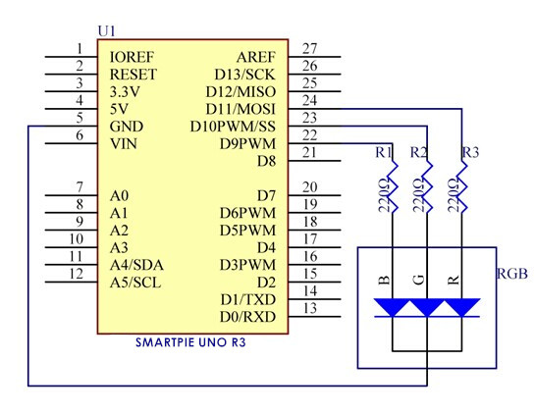

**Step 2:** Program (please go to our official website  [www.RobotLinking.com](http://www.sunfounder.com/) to download related

code by clicking LEARN -> Get Tutorials)

**Step 3:** Compile the program

**Step 4:** Burn the program into RobotLinking Uno board

The RGB LED will appear red, green, and blue first, then red, orange, yellow, green, blue, indigo, and purple.

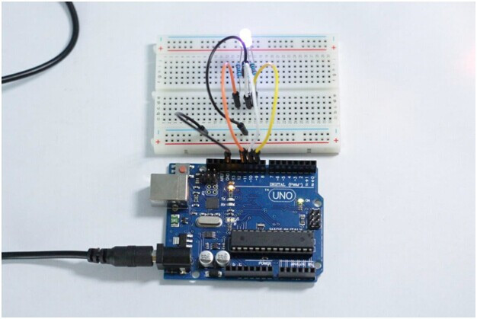

**Experimental Summary**

You should now understand how to use RGB LEDs. If you combine these LEDs with other components we have learned about previously, then you can create some dazzling interactive works.

**Lesson 7 DC Motor Control**

**Introduction**

In this experiment, we will learn how to control the direction and speed of a small-sized direct current motor (DC motor) by using the driver chip L293D and the RobotLinking Uno board. In order to make it easier for beginners, we will let the DC motor rotate left and right, accelerate and decelerate automatically.

**Components**

- 1 * Small-sized DC motor

- 1 * L293D

- 1 * RobotLinking Uno board

- 1 * Breadboard

- 1 * USB cable

- Jumper wires

**Principle**

L293D

This is a very practical chip that can independently control two DC motors. In this experiment, we’ll just use half of the chip. Since most pins on the right of the chip are used to control the second motor, we won’t connect these pins.

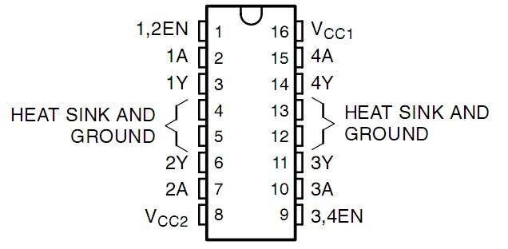

L293D has two pins (Vcc1 and Vcc2) for power supply. Thereinto, Vcc2 is used to supply power for the motor, while Vcc1 is used to supply power for the chip. Since we use a small-sized DC motor, we connect both pins to +5V. If you use a motor with more power consumption, you should connect Vcc2 to the external power supply. At the same time, the GND of L293D should be connected to the GND of the RobotLinking Uno board.

DC Motor Specifications

Voltage: 3-6V

Main Size: length 25mm, thickness 15mm, width 20mm

Motor Shaft Length: 9mm, Shaft Diameter 2mm

Rated Voltage: 3v

Reference Current: 0.35-0.4A

3v Rotating Speed: 13000 RPM

**Experimental Procedures**

**Step 1:** Connect circuit as shown in the following diagram:

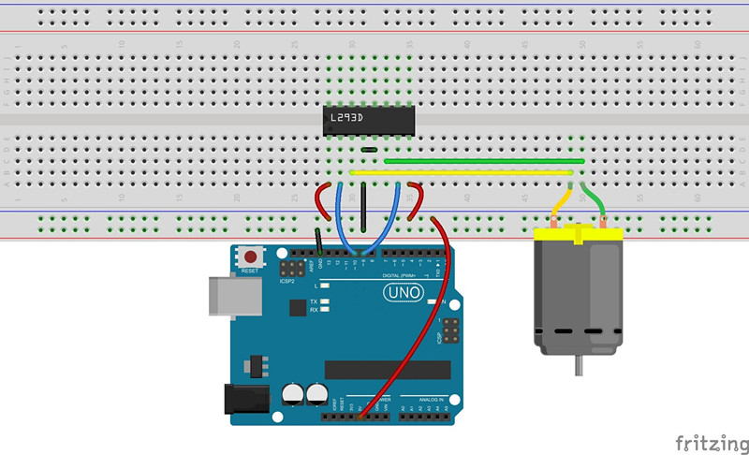

The corresponding schematic diagram is as follows:

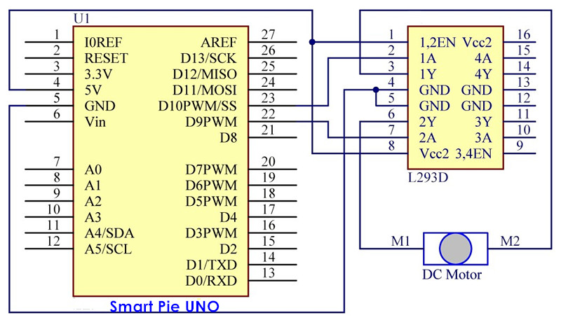

**Step 2:** Program (please go to our official website  [www.RobotLinking.com](http://www.sunfounder.com/) to download related code or get the code from the CD.)

**Step 3:** Compile the program

**Step 4:** Burn the compiled program into RobotLinking Uno board

The DC motor will begin rotating left and right, and its speed will vary accordingly.

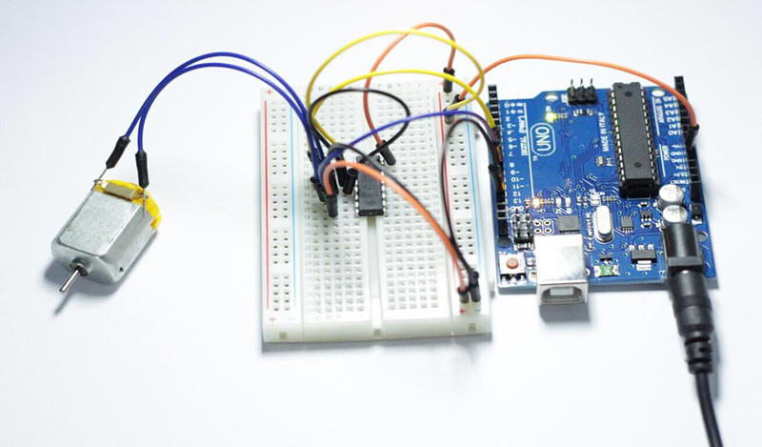

Further Exploration

Try to modify the code and add a potentiometer to adjust the speed of the motor. You can also add a button to control the rotation direction

**Lesson 8 LCD1602**

**Introduction**

In this experiment, we will use the RobotLinking Uno board to directly drive LCD1602 to display characters.

**Components**

- 1 * RobotLinking Uno board

- 1 * Breadboard

- 1 * LCD1602

- 1 * Potentiometer (50kΩ)

- Jumper wires

- 1 * USB cable

**Principle**

Generally speaking, LCD1602 has parallel ports, that is, it needs to control several pins at the same time. LCD1602 can be categorized into an eight-port connection and four-port connection. If the eight-port connection is used, then the digital ports of the RobotLinking Uno board are basically completely occupied. If you want to connect more sensors, there will be no ports available. Therefore, we will use the four-port connection.

Introduction to the pins of LCD1602:

**VSS:** A pin that connects to ground

**VDD:** A pin that connects to a +5V power supply

**VO:** A pin that adjust the contrast of LCD1602

**RS:** A register select pin that controls where in the LCD’s memory you are writing data to. You can select either the data register, which holds what goes on the screen, or an instruction register, which is where the LCD’s controller looks for instructions on what to do next.

**R/W:** A Read/Write pin that selects reading mode or writing mode

**E:** An enabling pin that, when supplied with low-level energy, causes the LDC module to execute relevant instructions.

**D0-D7：**Pins that read and write data

**A and K:** Pins that control the LED backlight

In this experiment, we will use a 50KΩ potentiometer to adjust the contrast of LCD1602 to display characters or figures however you want. For programming, we will optimize it by calling function libraries.

**Experimental Procedures**

**Step 1:** Connect circuit as shown in the following diagram (please make sure pins are connected correctly. Otherwise, characters will not display properly):

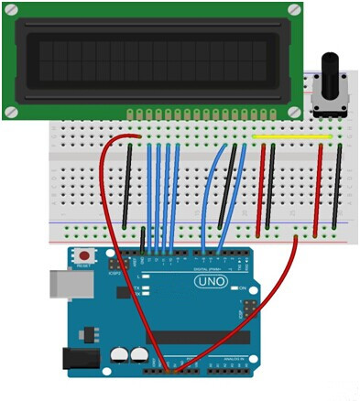

The corresponding schematic diagram is as follows:

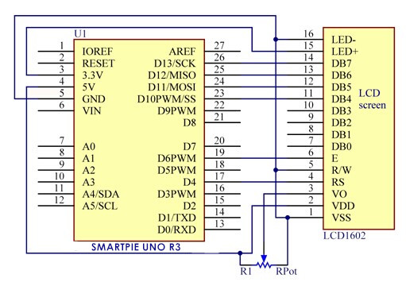

**Step 2:** Program (please go to our official website  [www.RobotLinking.com](http://www.sunfounder.com/) to download related code or get the code from CD.)

**Step 3:** Compile the program

**Step 4:** Burn the program into RobotLinking Uno board

You should now see your LCD1602 display the flowing characters "ROBOTLINKING" and "hello, world".

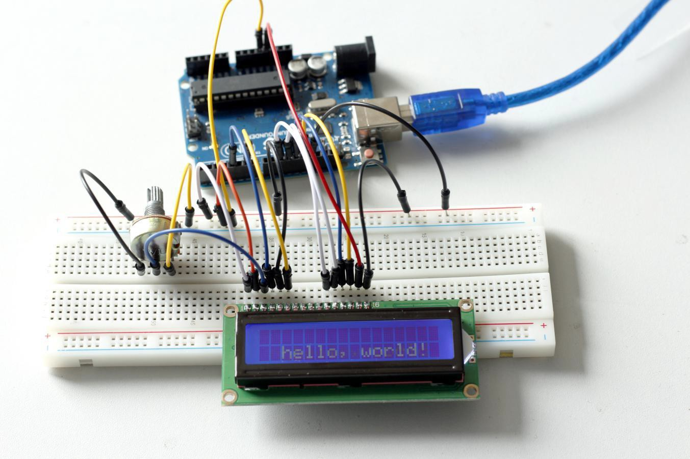

**Experimental Summary**

Through this experiment, you’ve learned how to drive LCD1602. Now you can create your own messages to display! You can also try letting your LCD1602 display numbers.

**Lesson 9 Serial Monitor**

**Introduction**

In this experiment, we will learn how to turn LEDs on or off on a RobotLinking Uno board through a computer and the serial monitor. The serial port is connected to the computer and the RobotLinking Uno board. We can send and receive data via the serial port and can control the RobotLinking Uno board through the keyboard.

In this experiment, you can input any color among red, green, and blue into the serial monitor of the computer. The corresponding LED on the RobotLinking Uno board will then light up.

**Components**

- 1 * RobotLinking Uno board

- 1 * Breadboard

- 3 * LED

- 3 * Resistor (220Ω)

- Jumper wires

- 1 * USB cable

**Principle**

Here, the serial port is a transfer station for communication between the computer and the RobotLinking Uno board. The computer inputs data to the serial port, and then the RobotLinking Uno board reads the data via USB data cable. After that, the RobotLinking Uno board will perform related operations according to the data.

**Experimental Procedures**

**Step 1:** Connect the RobotLinking Uno board to your computer via USB data cable. Open the serial monitor and input red, green, blue, or any other characters or character strings.

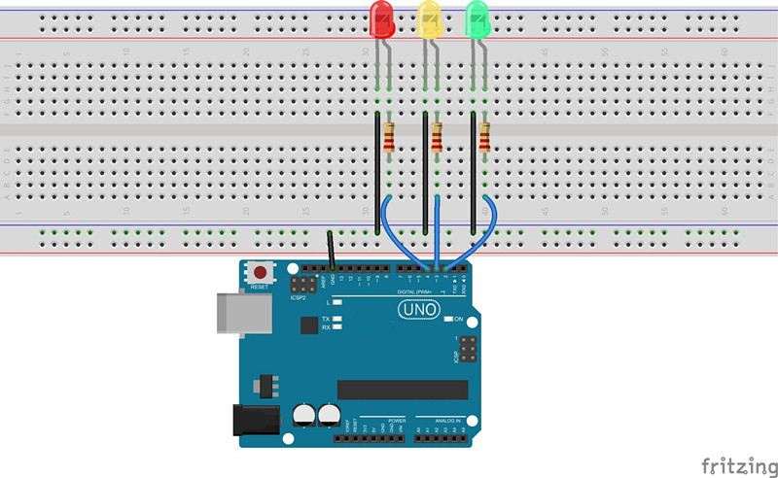

The corresponding schematic diagram is as follows:

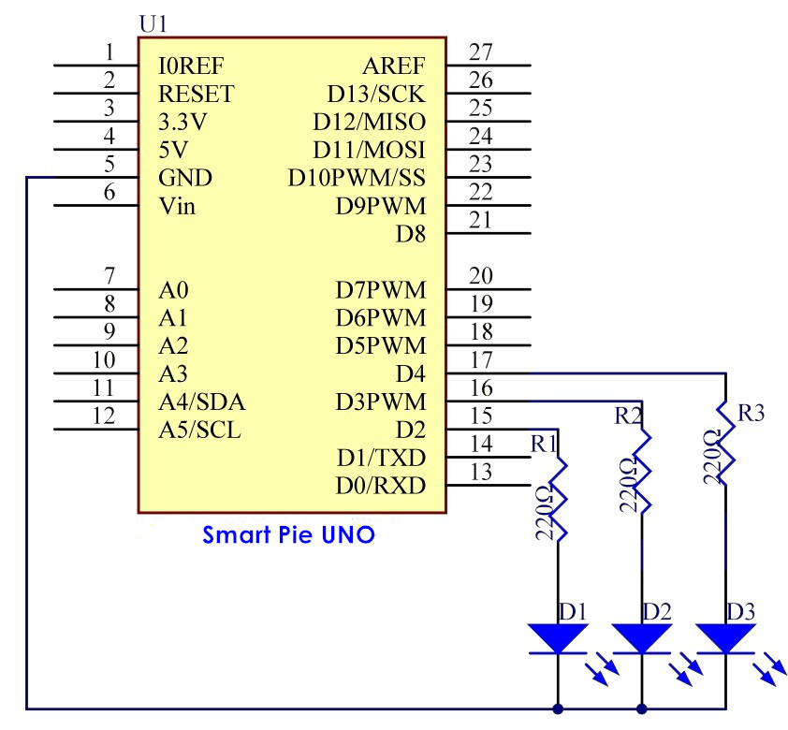

**Step 2:** Program (please go to our official website  [www.RobotLinking.com](http://www.sunfounder.com/) to download related code or get the code from CD.)

**Step 3:** Compile the program

**Step 4:** Burn the program into the RobotLinking Uno board

Now, if you click the icon on the upper-right corner of RobotLinking Uno IDE, you will see the serial monitor window pop up as shown in the following picture.

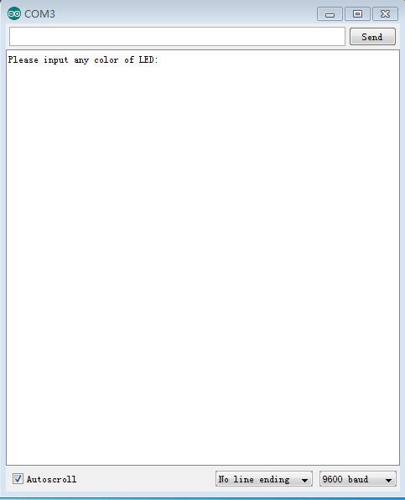

With this window, you can not only send information from your computer to the RobotLinking Uno board via USB cable but also receive information from the board and display it on the screen. When you open the serial monitor, it will display **"Please input any color of LED:**". You can input any color among red, green, and blue, and then click **Send**. The corresponding LED

on the RobotLinking Uno board will light up. However, if you input any color other than these

three, all the LEDs will turn off.

For example, if you input red, you will see the red LED light up.

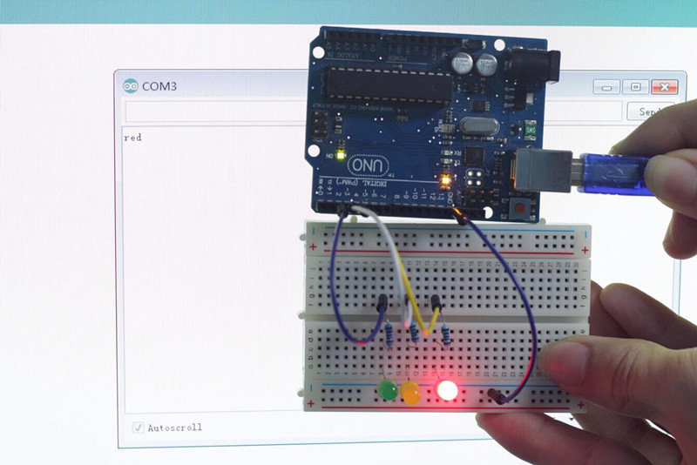

**Experimental Summary**

This experiment is meant to help you understand communication between your computer and the RobotLinking Uno board. You can modify the source code we provided. For example, if you input a number into the serial monitor, the corresponding LED will light up.

**Lesson 10 7-Segment Display**

**Introduction**

In this lesson, we will learn to use a 7-segment display made up of an array of common cathode LEDs parallel connected together. It is a simple and common component for displaying numbers or characters. The code we will use this time illuminates only one light per unit time. The high refresh rate – higher than the resolution speed of the naked eye – enables us to see the numbers clearly. The 7-segment display also has the advantage of high, uniform luminance.

**Components**

- 1 * RobotLinking Uno board

- 1 * 7-segment display

- 8 * Resistor (220Ω)

- 1 * USB cable

- Jumper wires

- 1 * Breadboard

**Principle**

The 7-segment display consists of seven LEDs arranged in a rectangular fashion. Each of the seven LEDs is called a segment because when illuminated the segment forms part of a numerical digit (both Decimal and Hex) to be displayed. An additional 8th LED is sometimes used within the same package thus allowing the indication of a decimal point (DP) when two or more 7-segment displays are connected together to display numbers greater than ten.

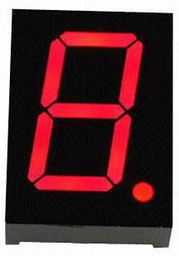

Each one of the seven LEDs in the display is given a positional segment with one of its connection pins being brought straight out of the rectangular plastic package. These LED pins

are labeled from a through to g representing each individual LED. The other LED pins are

connected together and wired to form a common pin.

So by forward biasing the appropriate pins of the LED segments in a particular order, some segments will be light and others will be dark allowing the desired character pattern of the number to be generated on the display. This then allows us to display each of the ten decimal digits 0 through to 9 on the same 7-segment display.

The display’s common pin is generally used to identify which type of 7-segment display it is. As each LED has two connecting pins, one called the "Anode" and the other "Cathode", there are therefore two types of LED 7-segment display called: Common Cathode (CC) and Common Anode (CA).

The difference between the two displays, as their name suggests, is that the common cathode has all the cathodes of the 7-segments connected directly together and the common anode has all the anodes of the 7-segments connected together.

The Common Cathode (CC) – In the common cathode display, all the cathode connections of the LED segments are joined together to logic "0" or ground. The individual segments are illuminated by application of a "HIGH", or logic "1" signal via a current limiting resistor to forward bias the individual Anode terminals (a-g).

**Common Cathode 7-Segment Display**

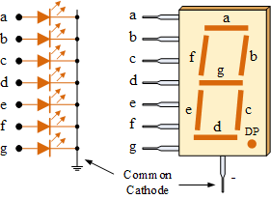

The Common Anode (CA) – In the common anode display, all the anode connections of the LED segments are joined together to logic "1". The individual segments are illuminated by applying a ground, logic "0" or "LOW" signal via a suitable current limiting resistor to the Cathode of the particular segment (a-g).

**Common Anode 7-Segment Display**

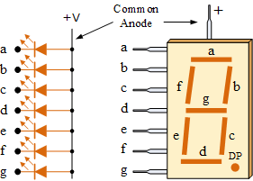

**Experimental Procedures**

**Step 1:** Connect circuit according to real connection diagram shown below:

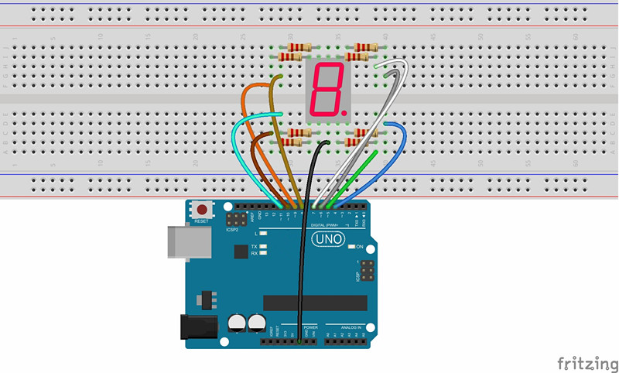

The corresponding schematic diagram is as follows:



**Step 2:** Program (please go to our official website  [www.RobotLinking.com](http://www.sunfounder.com/) to download related code or get the code from CD.)

**Step 3:** Compile the program

**Step 4:** Burn the program into RobotLinking Uno board

You should now see the 7-segment display cycle from 0 to F.

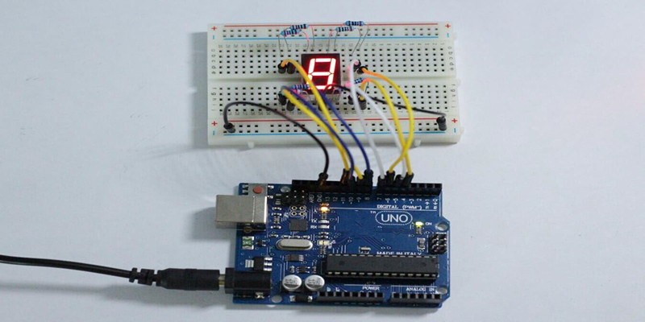

Experimental Summary

In this experiment we learn how to directly drive a single 7-segment display via the RobotLinking Uno board. You can also try to modify the code to display numbers even patterns

**Lesson 11 74HC595**

**Introduction**

In this experiment, we will learn how to use 74HC595 to drive a single 7-segment display to display numbers.

Generally speaking, there are two methods to drive a single 7-segment display. One is to connect 8 pins directly to eight ports on the RobotLinking Uno board, which we did in the previous experiment. The other is to connect 74HC595 to three ports of the RobotLinking Uno board and connect the 7-segment display to 74HC595. In this experiment, we will use the latter method. The advantage of this method is that you can save five ports, which is very important considering the RobotLinking Uno board’s limited ports.

**Components**

- 8 * Resistor (220Ω)

- 1 * 74HC595

- 1 * RobotLinking Uno board

- Jumper wires

- 1 * Breadboard

- 1 * USB cable

- 1 * 7-segment display

**Principle**

**74HC595 Principle of Operation**

74HC595 has an 8-bit shift register and memory with a three-state output function. Its main function is to transform serial data input into parallel data output so that you can save the IO port of MCU. 74HC595 is mainly used in multipath LED indication or multi-bit segment display driving. At the same time, it supports three-state output. When the 13th pin is at high level, there will be no output in 74HC595. With a data latching function, 74HC595 does not affect the instant output during the shifting process; with a data output function, 74HC595 enables you to cascade 74HC595 more conveniently.

|  |  |  |
| --- | --- | --- |
|  |  |  |
|  |  |
|  |  |
|  |  |
|  |  |
|  |  |
|  |  |
|  |  |
|  |  |

Introduce the pin function of 74HC595:



**Q0-Q7**: 8-bit parallel data output pins, able to control 8 LEDs or 8 pins of 7-segment display directly.

**Q7’**: Series output pin connected to DS pin of the next 74HC595 to connect multiple 595s in series

**MR**: Reset pin, effective at low level; here it is directly connected to 5V.

**SH**: Time sequence input of shift register. On the rising edge, the data in shift register moves successively one bit, i.e. data in Q1 moves to Q2, and so forth. While on the falling edge, the data in shift register remain unchanged.

**ST**: Time sequence input of memory register. On the rising edge, data in the shift register moves into memory register.

**OE** : Output enable pin, effective at low level, connected to the ground directly.

**Ds** : Serial data input pin **VCC**: The power supply **GND**: The ground

Here the shiftout function is applied, which comes with the RobotLinking IDE when programming. Simply input a number from 0 to 255 and the memory register can transform it into an 8-bit binary number and output it parallel. This allows you to easily control the 8 pins of the 7- segment display and create any pattern you want.

**Experimental Procedures**

**Step 1:** Connect circuit as shown in the following diagram:

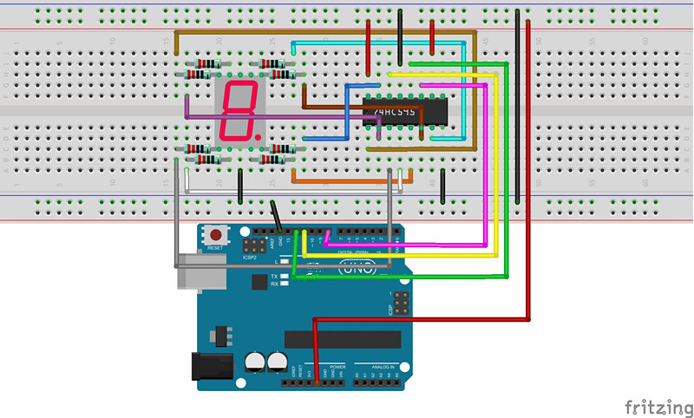

The corresponding schematic diagram is as follows:



**Step 2:** Program (please go to our official website  [www.RobotLinking.com](http://www.sunfounder.com/) to download related

code or get the code from CD.)

**Step 3:** Compile the program

**Step 4:** Burn the program into RobotLinking Uno board

You should now be able to see the 7-segment display cycle from 0 to F.

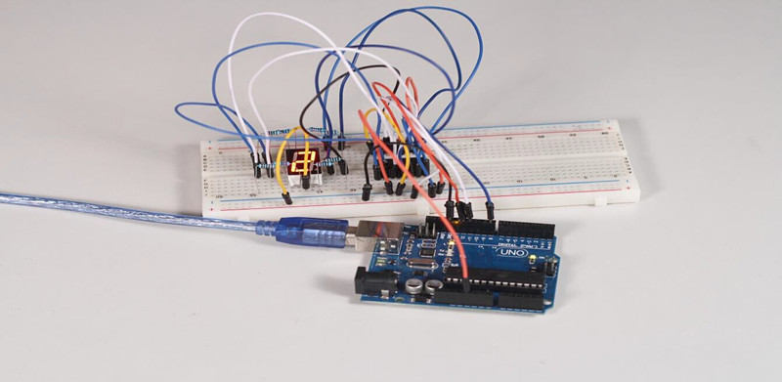

**Experimental Summary**

In this experiment, you have learned how to use 74HC595 to expand I/O ports, which is very practical. With more practice, this will become a priceless skill.

**Lesson 12 Dot-Matrix Display**

**Introduction**

With low-voltage scanning, LED dot-matrix displays have advantages such as power saving, long service life, low cost, high brightness, wide angle of view, long visual range, waterproof, and numerous specifications. LED dot-matrix displays can meet the needs of different applications and thus have a broad development prospect. This time, we will conduct an LED dot-matrix experiment to experience its charm firsthand.

**Components**

- 1 * RobotLinking Uno board

- 1 * 8*8 dot-matrix

- 8 * Resistor (220Ω)

- 1 * Breadboard

- Jumper wires

- 2 * 74HC595

- 1 * USB cable

**Principle**

The external view of a dot-matrix is shown as follows:

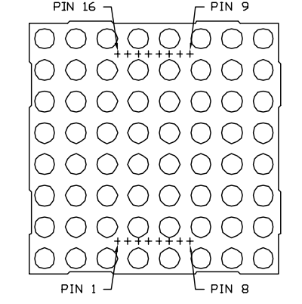

The display principle of the 8*8 dot-matrix:

The 8*8 dot-matrix is made up of sixty-four LEDs, and each LED is placed at the cross point of a row and a column. When the electrical level of a certain row is 1 and the electrical level of a

certain column is 0, the corresponding LED will light up. If you want to light the LED on the first

dot, you should set pin 9 to high level and pin 13 to low level. If you want to light LEDs on the first row, you should set pin 9 to high level and pins 13, 3, 4, 10, 6, 11, 15 and 16 to low level. If you want to light the LEDs on the first column, set pin 13 to low level and pins 9, 14, 8, 12, 1, 7,

2 and 5 to high level.

The internal view of a dot-matrix is shown as follows:

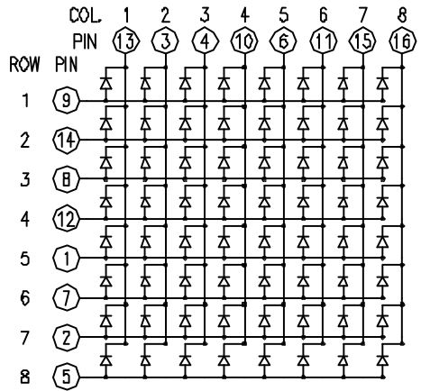

The principle of 74HC595 has been previously illustrated. One chip is used to control the rows of the dot-matrix while the other chip is used to control the columns.

**Experimental Procedures**

**Step 1:** Connect circuit as shown in the following diagram:

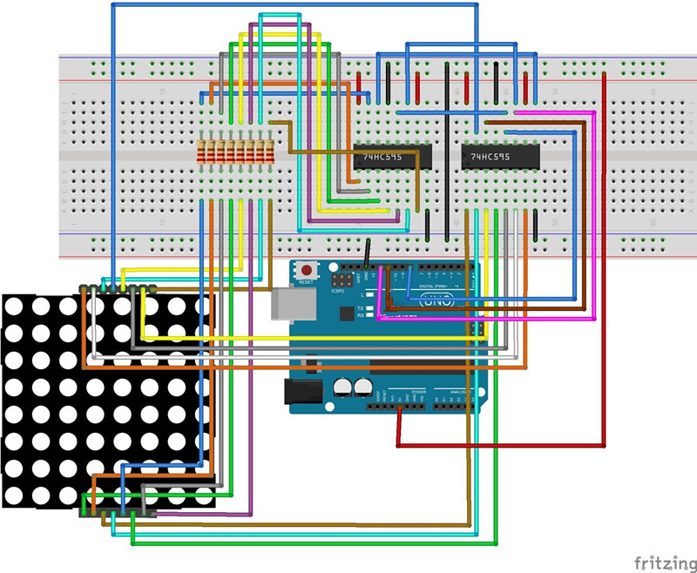

The corresponding schematic diagram is as follows:

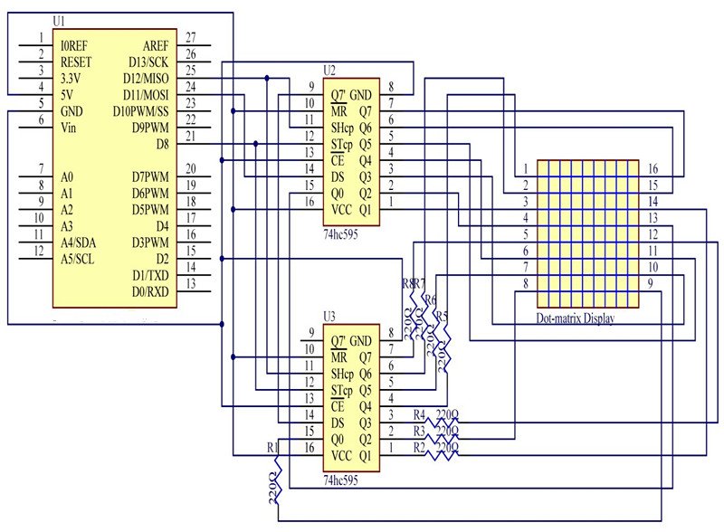

**Step 2:** Program (please go to our official website  [www.RobotLinking.com](http://www.sunfounder.com/) to download related

code or get the code from CD.)

**Step 3:** Compile the program

**Step 4:** Burn the program into RobotLinking Uno board

The dot-matrix will display 0 to F circularly.

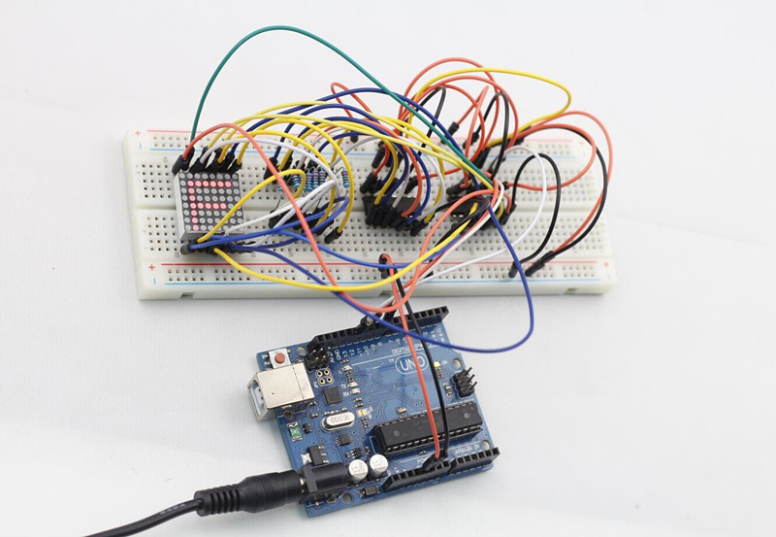

**Experimental Summary**

You have now learned how to drive a dot-matrix. Try modifying the code to let your dot-matrix display other letters, numbers, or even patterns.

**Lesson 13 NE555 Timer**

**Introduction**

If you ask anyone in the know to rank the most commonly and widely applied integrated circuits, the famous 555 time base integrated circuit would certainly be at the top of the list. The

555 – a mixed circuit composed of analog and digital circuits – integrates analogue and logical functions into an independent integrated circuit, and hence tremendously expands the

application range of analog integrated circuits. The 555 is widely used in various timers, pulse

generators, and oscillators. In this experiment, we will use the RobotLinking Uno board to test the frequencies of square waves generated by the 555 oscillating circuit and show them on a serial monitor.

**Components**

- 1 * RobotLinking Uno board

- 1 * USB cable

- Jumper wires

- 1 * Breadboard

- 1 * NE555

- 2 * 104 ceramic capacitor

- 1 * Potentiometer (50KΩ)

- 1 * Resistor (10KΩ)

**Principle**

The 555 integrated circuit was originally used as a timer, hence the name 555 time base circuit. It is now widely used in various electronic products because of its reliability, convenience, and low price. The 555 is a complex hybrid circuit with dozens of components such as a divider, comparator, basic R-S trigger, discharge tube, and buffer.

555 chip pins are introduced as follows:

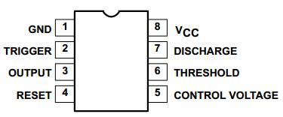

As shown in the picture, the 555 integrated circuit is dual in-line with the 8-pin package. Thus:

• Pin 1 (**GND**): the ground;

• Pin 2 (**TRIGGER** ): the input of lower comparator;

• Pin 3 (**OUTPUT)**: having two states of 0 and 1 decided by the input electrical level;

• Pin 4 (**RESET**): output low level when supplied a low voltage level;

• Pin 5 (**CONTROL VOLTAGE**): changing the upper and lower level trigger values;

• Pin 6 (**THRESHOLD)**: the input of upper comparator;

• Pin 7 (**DISCHARGE)**: having two states of suspension and ground connection also decided by input, and the output of the internal discharge tube;

• Pin 8 (**VCC**): the power supply;

**Experimental Procedures**

**Step 1:** Connect circuit as shown in the following diagram:

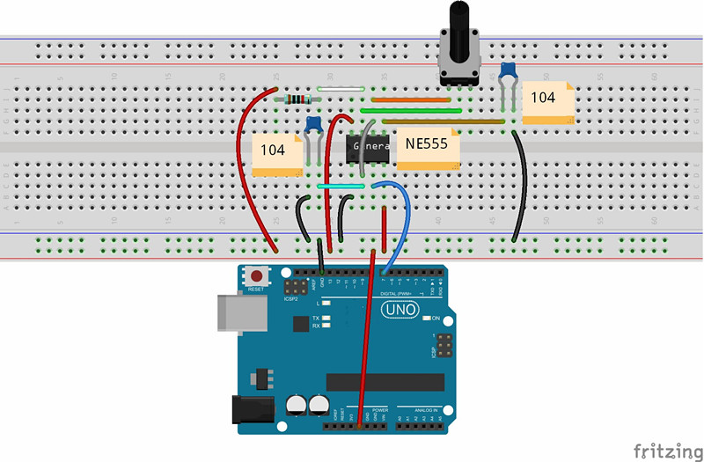

The corresponding schematic diagram is as follows:

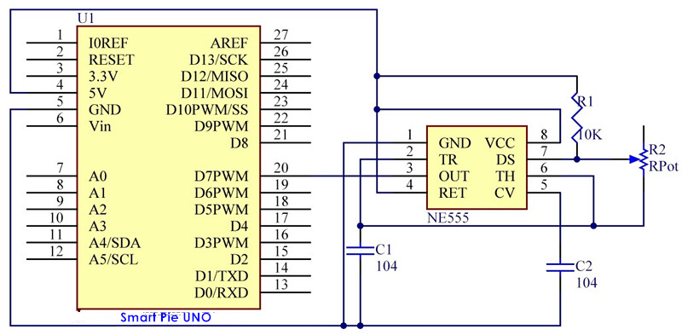

**Step 2:** Program (please go to our official website  [www.RobotLinking.com](http://www.sunfounder.com/) to download related code or get the code from CD.)

**Step 3:** Compile the program

**Step 4:** Burn the program into RobotLinking Uno board

After burning the program, open the serial monitor and you will see the picture shown below. If you rotate the potentiometer, the length of the pulse (in microsecond) displayed will change accordingly.

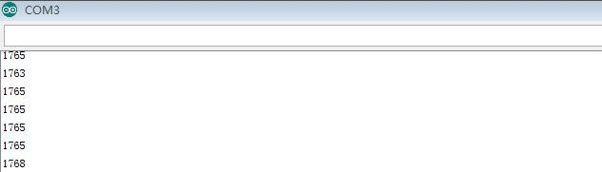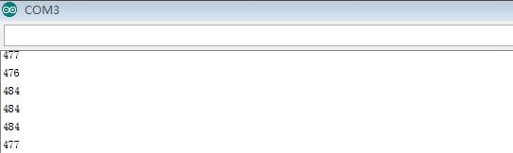

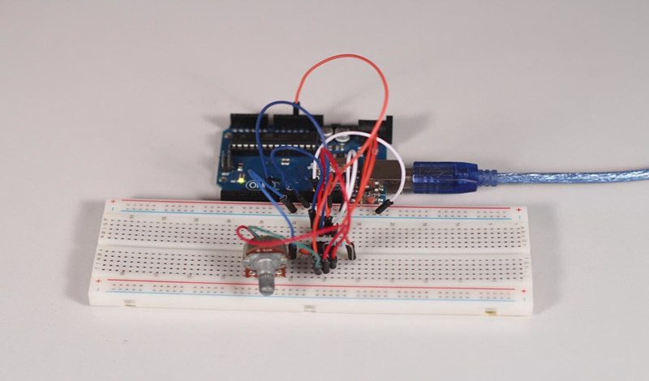

**Experimental Summary**

In this experiment, we learned how to use NE555. Try modifying the code and printing the frequency values measured on your LCD1602.

**Lesson 14 Rotary Encoder**

**Introduction**

In this experiment, we will learn how to use rotary encoders. A rotary encoder is an [electro- mechanical](http://en.wikipedia.org/wiki/Electro-mechanical) device that converts the [angular](http://en.wikipedia.org/wiki/Angle) position or motion of a shaft or axle to an analog or digital code. Rotary encoders are usually placed at the side which is perpendicular to the shaft. Rotary encoders act as sensors for detecting angle, speed, length, position and acceleration in automation field.

**Components**

- 1 * RobotLinking Uno board

- 1 * USB cable

- 1 * Breadboard

- 1 * Rotary encoder module

- Jumper wires

**Principle**

There are two main types of rotary encoders: absolute and incremental (relative). The output of absolute encoders indicates the current position of the shaft, making them [angle transducers.](http://en.wikipedia.org/wiki/Transducer) The output of incremental encoders provides information about the motion of the shaft, which is typically further processed elsewhere into information such as speed, distance, and position.

In this experiment, we will use the latter.

An incremental encoder is a rotary sensor intended to turn rotational displacement into a series of digital pulse signals which are then used to control the angular displacement. It generates two-phase square waves whose phase difference is 90°. Usually the two-phase square waves are called channel A and channel B as shown below:

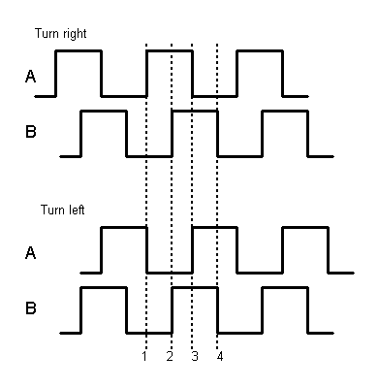

It’s difficult to distinguish left turn and right turn during SCM programming. However, when

using an oscilloscope to observe the left and right turn of a switch, you will find that a phase

difference exists between the signals of the two output pins. The phase difference is shown as

follows:

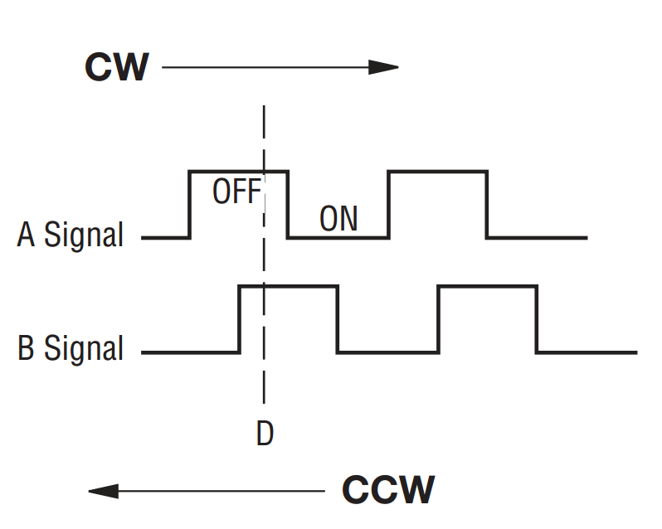

If both channel A and channel B are high, the switch rotates clockwise; if channel A is high and channel B is low, the switch rotates counterclockwise. As a result, if channel A is high, you can judge whether the rotary encoder turns left or right as long as you know the state of channel B.

**Experimental Procedures**

**Step 1:** Connect circuit as shown in the following diagram:

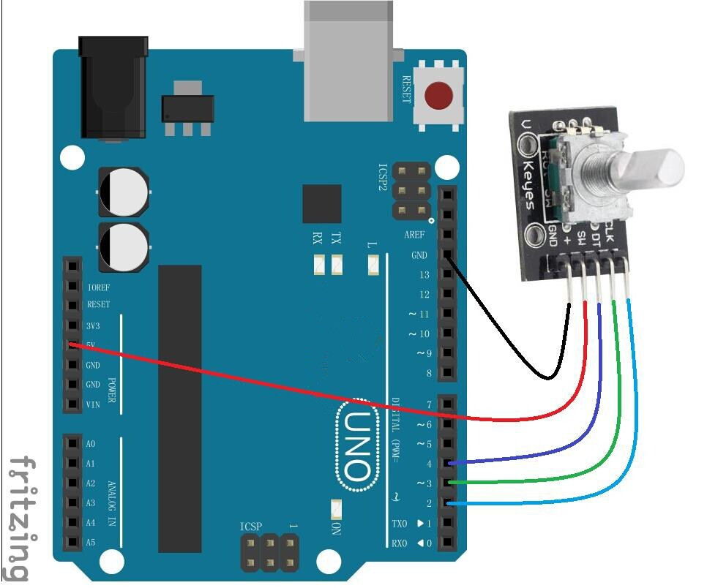

The corresponding schematic diagram is as follows:

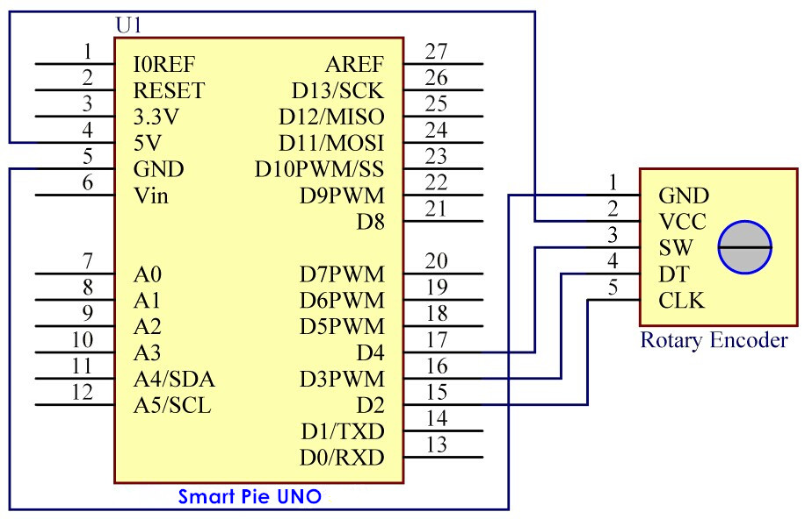

For convenience, we use a rotary encoder module. Connect pins + and GND of the rotary

encoder module to pins 5V and GND of the RobotLinking Uno board, and pins CLK and DT of the module to digital pins 2 and 3 of the board

**Step 2:** Program (please go to our official website  [www.RobotLinking.com](http://www.sunfounder.com/) to download related code or get the code from the CD.)

**Step 3:** Compile the program

**Step 4:** Burn the program into RobotLinking Uno board

You will see the angular displacement of the rotary encoder printed on the serial monitor of the computer. When the rotary encoder turns clockwise, the angular displacement is increased; when it turns counterclockwise, it’s decreased. If you press the switch on the rotary encoder, related readings will return to zero.

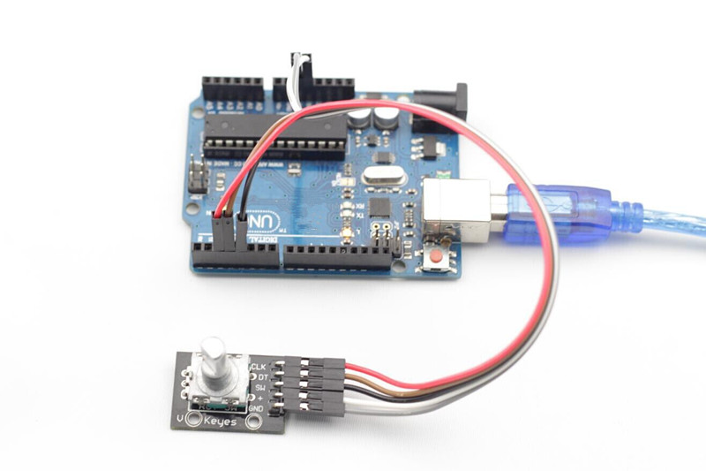

**Experimental Summary**

In this lesson, you have learned the basic usage of rotary encoders through the experiment. Try modifying the experiment to print the displayed data on LCD1602.

**Lesson 15 ADXL335**

**Introduction**

In this experiment, we will learn how to use the ADXL335. The ADXL335 is a small, thin, low power, complete 3-axis accelerometer with signal-conditioned voltage outputs. It measures acceleration with a minimum full-scale range of ±3g. It can measure the static acceleration of gravity in tilt-sensing applications, as well as dynamic acceleration resulting from motion, shock, or vibration.

**Components**

- 1 * RobotLinking Uno board

- 1 * Breadboard

- 1 * ADXL335 module

- 1 * USB cable

- Jumper wires

**Principle**

ADXL335

The operating voltage of ADXL335 ranges from 1.8V to 3.6V. The ADXL335 uses 5*5*2 mm LCC packaging when ambient temperature ranges from -55℃ to 125℃. This product is exceptionally light, and the size of the PCB module is only 16mm*20mm, as shown in the following picture. It’s quite convenient for embedding hardware for engineering projects. ADXL335 can obtain power from analog port A0 and A4 of the RobotLinking Uno board. However, for convenience, we directly supply 3.3V voltage from the RobotLinking Uno board to the ADXL335. Do not use the 5V voltage of the RobotLinking Uno board to supply power to the ADXL335.

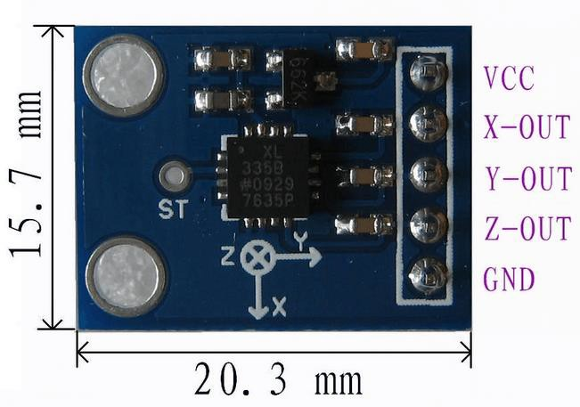

What the ADXL335 outputs are analog voltage values; therefore, what you need to do is collect

output voltage values when programming. Of course you also need to perform some engineering projects. If you want to test accurate figures, you need to edit more code according to relevant data manuals.

**Experimental Procedures**

**Step 1:** Connect circuit as shown in the following diagram:

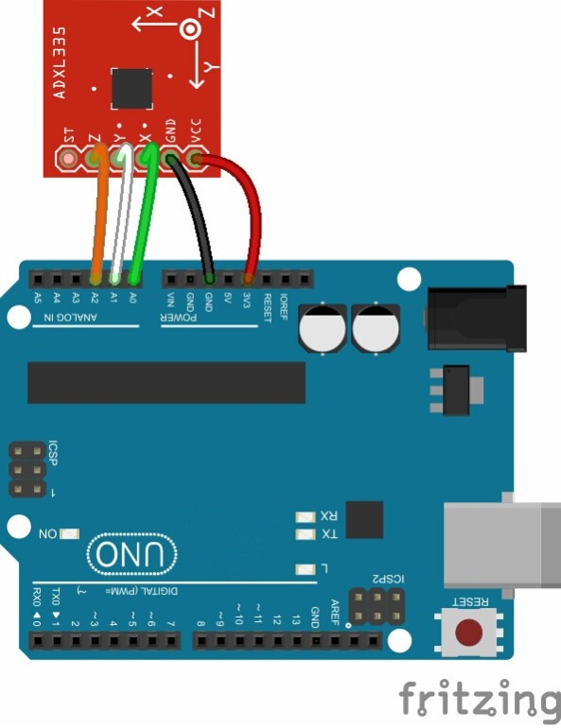

The corresponding schematic diagram is as follows:

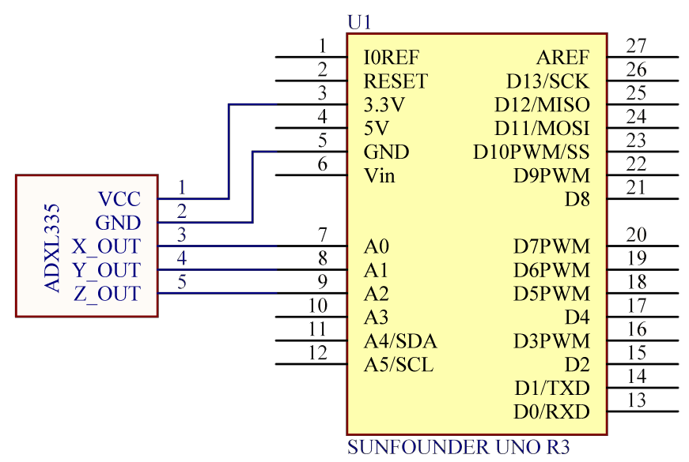

**Step 2:** Program (please go to our official website  [www.RobotLinking.com](http://www.sunfounder.com/) to download related code or get the code from CD.)

**Step 3:** Debug the program

**Step 4:** Burn the program into RobotLinking Uno board

After burning the program, open the serial monitor debugging window, where you can see the data detected being displayed. When the acceleration varies, the figure will vary accordingly.

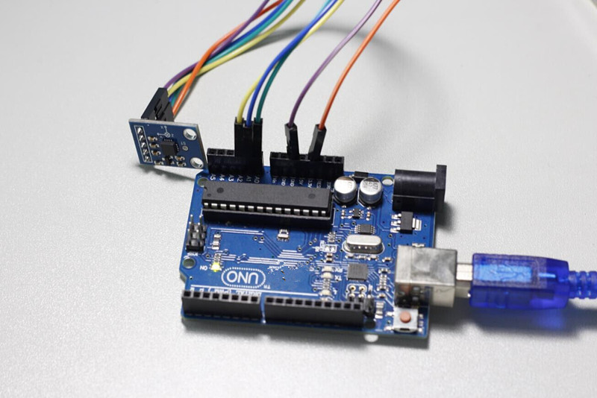

**Experimental Summary**

Now you have learned the basic usage of ADXL335 through this experiment. If you want your

ADXL335 to become more interesting, try modifying the code.

**Lesson 16 Simple Creation - Light Alarm**

**Introduction**

This experiment is a very interesting one – a DIY photistor. DIY photistors use the principle of glow effect and the photoelectric effect of LEDs. That is, LEDs will generate weak currents when being shined on by light. We use a transistor to amplify the currents and trigger the RobotLinking Uno board to detect them.

**Components**

- 1 * RobotLinking Uno board

- 1 * Breadboard

- 1 * USB cable

- Jumper wires

- 1 * Passive buzzer

- 1 * Resistor (10KΩ)

- 1 * LED

- 1 * NPN Transistor S8050

**Principle**

LEDs not only have a glow effect, but also a photoelectric effect. They will generate weak currents when exposed to light waves.

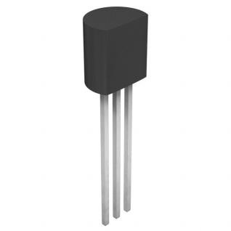

NPN Transistors are easy to use. The left pin is Emitter electrode, attached to the power source, the middle pin is Base, and the right pin is Collector. If only the middle pin has weak trigger currents, they will flow from left to right of the LED like a switch being opened.

A 10kΩ pull-down resistor is attached to the transistor output stage in order to avoid analog port suspending to interfere with signals and cause misjudgment.

**Experimental Procedures**

**Step 1:** Connect circuit as shown in the following diagram

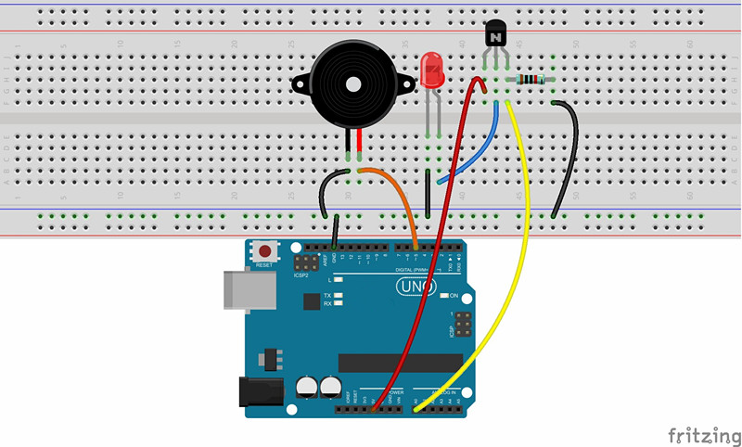

The corresponding schematic diagram is as follows:

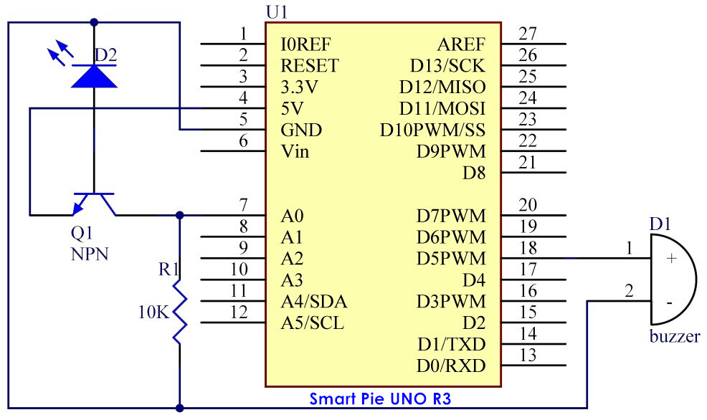

**Step 2:** Program (please go to our official website  [www.RobotLinking.com](http://www.sunfounder.com/) to download related code or get the code from CD.)

**Step 3:** Compile the program

**Step 4:** Burn the program into RobotLinking Uno board

Now, you can hear that the buzzer make sounds when the LED is shined.

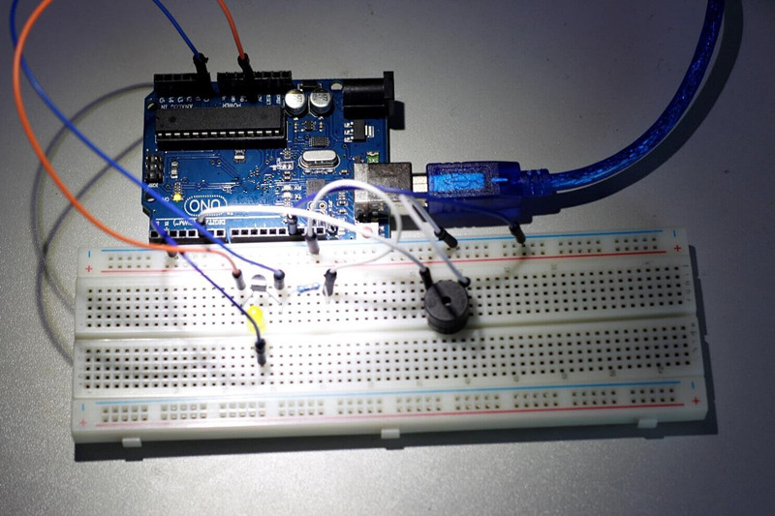

**Experimental Summary**

Through this experiment, you should have gained a basic understanding of analog circuits. You can also create many interesting interactive works by combining analog circuits and the RobotLinking Uno board. This is just the beginning!

**Lesson 17 Simple Creation - Traffic Light**

**Introduction**

We will conduct an experiment centered on traffic lights today. Rotating a rotary encoder will change the frequency of a traffic light being turned on sequentially.

**Components**

- 1 * RobotLinking Uno board

- 1 * Breadboard

- 1 * USB cable

- Jumper wires

- 1 * Rotary encoder

- 3 * LED

- 3 * Resistor (220Ω)

**Principle**

For a real traffic light, the time length for displaying red and green is much longer than yellow. As a result, we define two cycles with a program: a short cycle and a long cycle. In a short cycle, the traffic light changes its order at a rate of roughly once per second. On the other hand, the long cycle is changed by a rotary encoder determining the time length of red and green light.

**Experimental Procedures**

**Step 1:** Connect circuit as shown in the following diagram

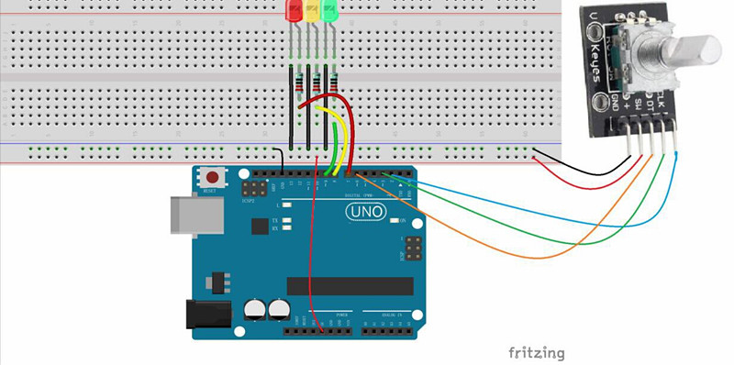

The corresponding schematic diagram is as follows:

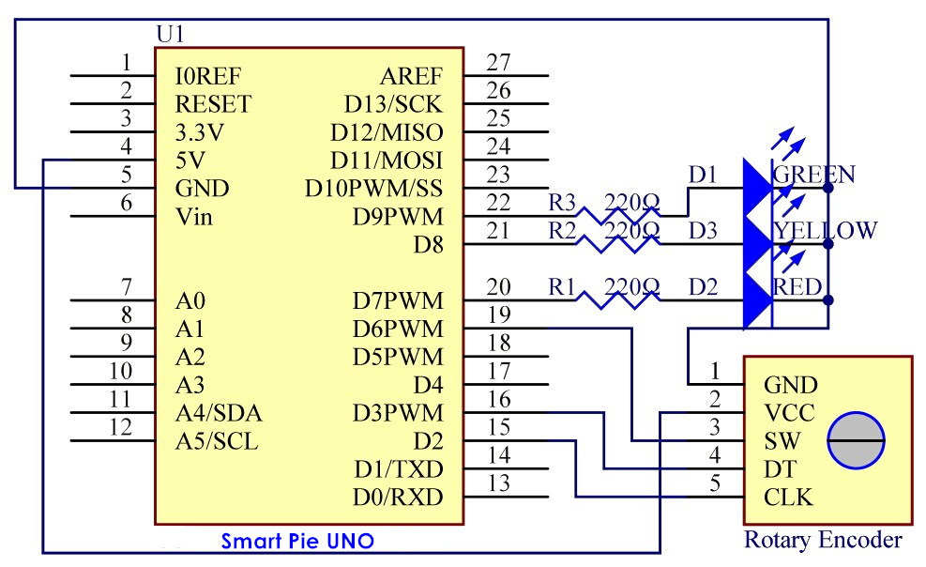

**Step 2:** Program (please go to our official website  [www.RobotLinking.com](http://www.sunfounder.com/) to download related code or get the code from the CD.)

**Step 3:** Compile the program

**Step 4:** Burn the program into RobotLinking Uno board

You will see the red LED light up first, then the red LED and yellow LED, followed by the green

LED, and finally the yellow LED again.

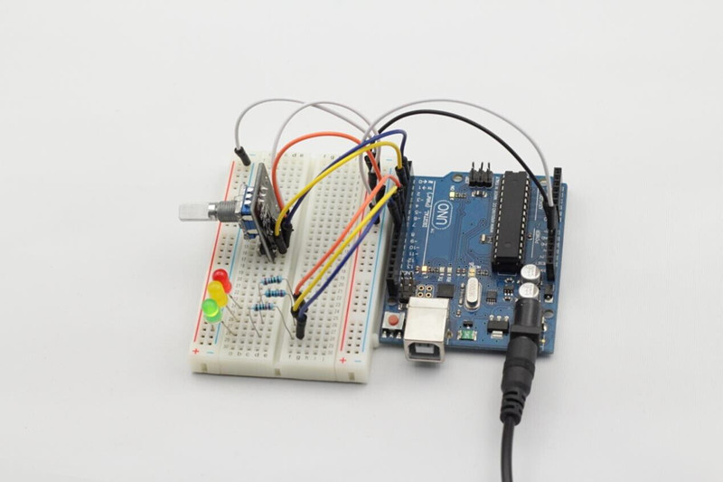

**Experimental Summary**

Through this experiment, you have learned the combination usage of a rotary encoder and LEDs. You should now have a deeper understanding of rotary encoders.

**Lesson 18 Simple Creation - Digital Dice**

**Introduction**

In previous experiments, we tested the single 7-segment display and controlled LEDs by pressing a button. Through them, we learned the basic usage of the two components. This time, we will combine a 7-segment display and a button together to create simple digital dice.

**Components**

- 1 * RobotLinking Uno board

- 1 * Breadboard

- 1 * USB cable

- Jumper wires

- 1 * Button

- 1 * Resistor (10KΩ)

- 8 * Resistor (220Ω)

- 1 * 7-segment display

- 1 * 104 ceramic capacitor

- 1 * 74HC595

**Principle**

The idea behind digital dice is very simple: a single 7-segment display circularly jumps from 1 to

6 rapidly. When the button is pressed, the jumping will slow down until it stops on a number three seconds later. When the button is pressed again, the process will repeat.

**Experimental Procedures**

**Step 1:** Connect circuit as shown in the following diagram:

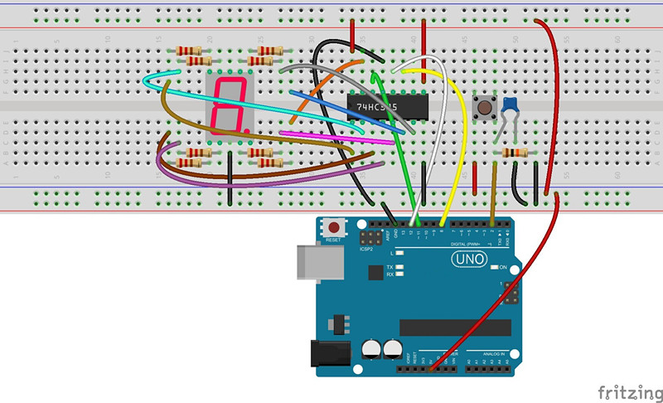

The corresponding schematic diagram is as follows:

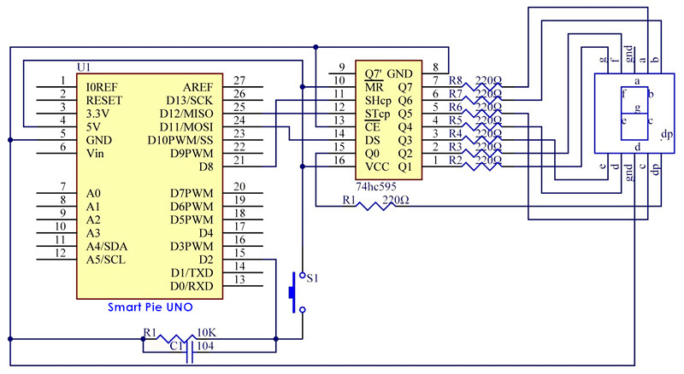

**Step 2:** Program (please go to our official website  [www.RobotLinking.com](http://www.sunfounder.com/) to download related code or get the code from the CD.)

**Step 3:** Compile the program

**Step 4:** Burn the program into RobotLinking Uno board

You can now see the single 7-segment display jump between numbers from 1 to 6. When the button is pressed, the jumping will slow down until it stops three seconds later. If the button is pressed again, the process will repeat.

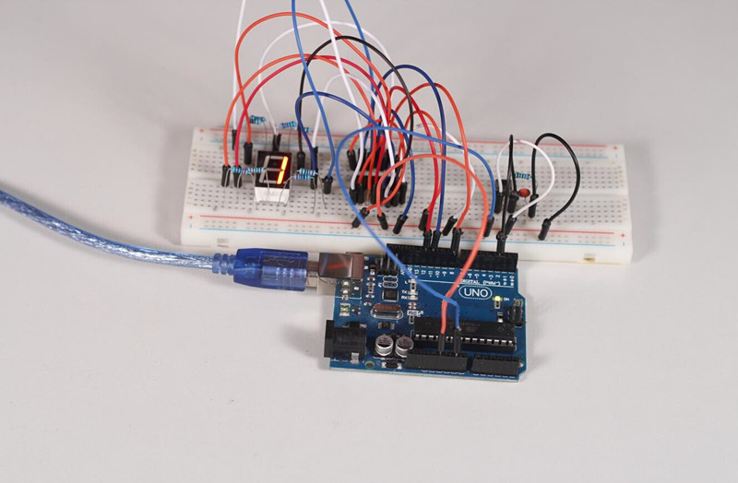

**Experimental Summary**

Through this experiment, you have learned the combination usage of a 7-segment display and a button. You can create many other things by using the button as an input device and the 7- segment display as a display device.

**Lesson 19 Simple Creation - Small Fan**

**Introduction**

In this experiment, we will combine a button and a motor to assemble a small simple fan. We can shift the rotational speed, or gear selection, of the fan by pressing the button.

**Components**

- 1 * RobotLinking Uno board

- 1 * Breadboard

- 1 * USB cable

- Jumper wires

- 1 * DC motor

- 1 * Resistor (10KΩ)

- 1 * Button

- 1 * Motor diver chip L293D

- 1 * 104 Ceramic Capacitor

- 1 * Fan

**Principle**

The principle of this experiment is to control the rotational speed of the motor by having it read the amount of times the button is pressed. After startup, the default gear is 0 and the fan will not rotate. If the button is pressed once, the small fan will enter gear 1 (low speed) and rotate slowly; if the button is pressed twice, it will enter gear 2 (medium speed) and rotate at a medium pace; if the button is pressed three times, it will enter gear 3 (high speed) and rotate rapidly. If the button is pressed four times, it will return to gear 0 and stop.

**Experimental Procedures**

**Step 1:** Connect circuit as shown in the following diagram:

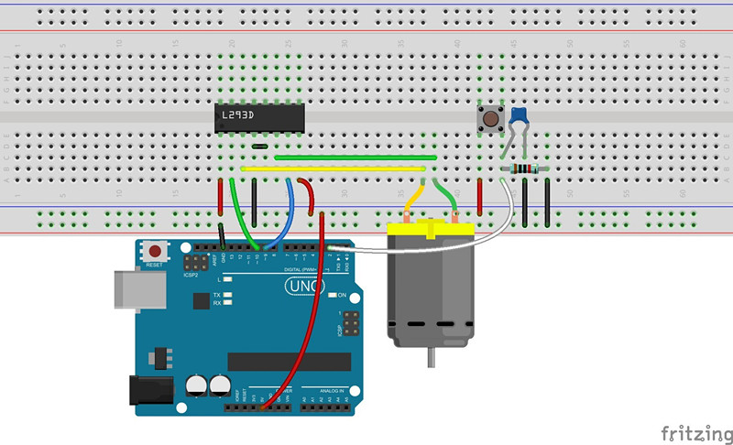

The corresponding schematic diagram is as follows:

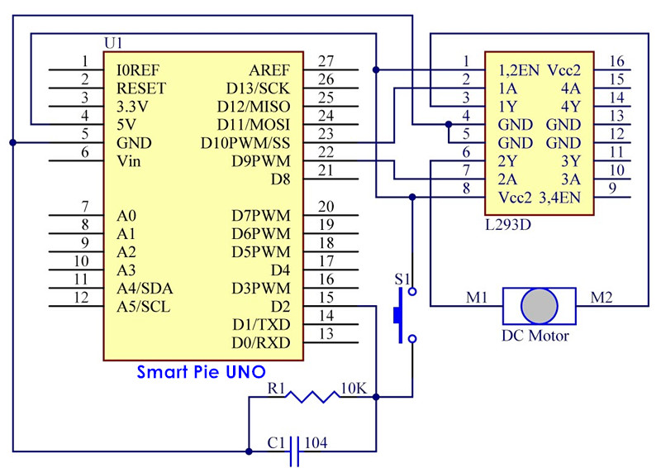

**Step 2:** Program (please go to our official website  [www.RobotLinking.com](http://www.sunfounder.com/) to download related or get the code from CD.)

**Step 3:** Compile the program

**Step 4:** Burn the program into RobotLinking Uno board

As explained above, the amount of times you press the button should change the rotation speed of the fan. Pressing it once will cause it to rotate slowly, while pressing it three times will cause it to rotate quickly, and pressing it four times will cause it to stop.

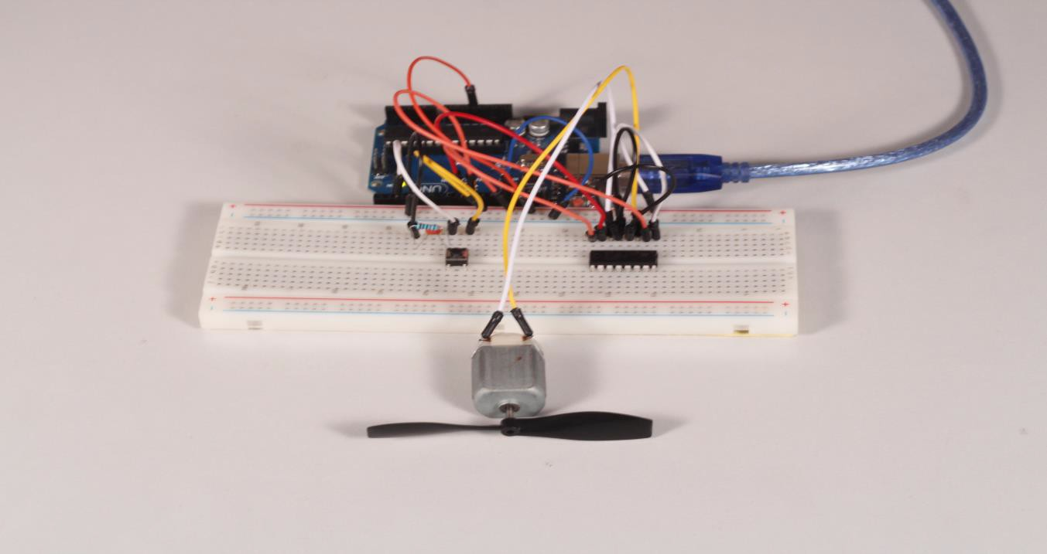

**Experimental Summary**

Through this experiment, we have learned the usage of motors in depth. I hope you can create more complex interactive works on your own!